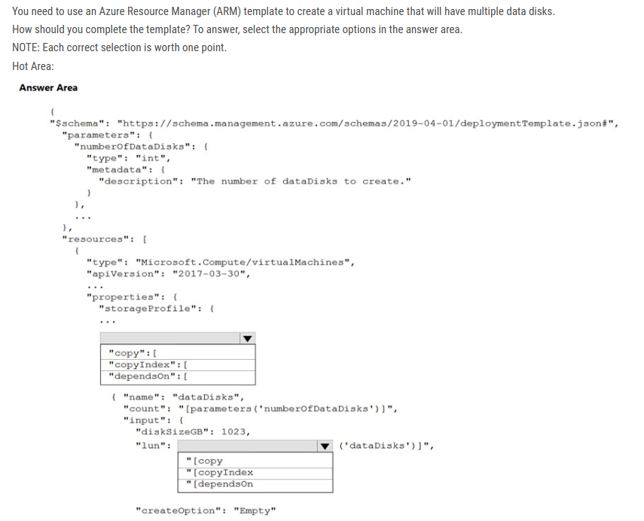

ANS: Copy, copyIndex

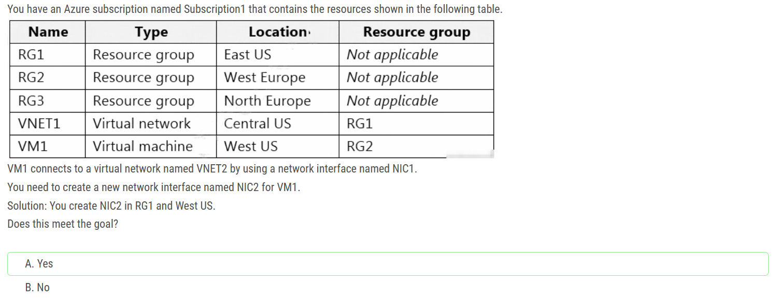

Each NIC attached to a VM must exist in the same location and subscription as the VM

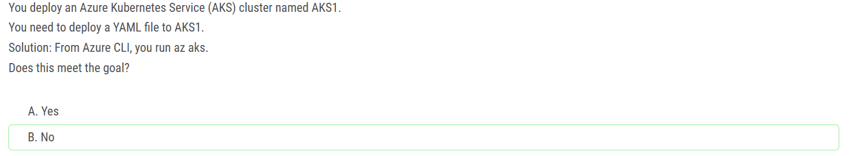

To deploy the YAML file you need to runs kubectl apply -f file_name.yaml

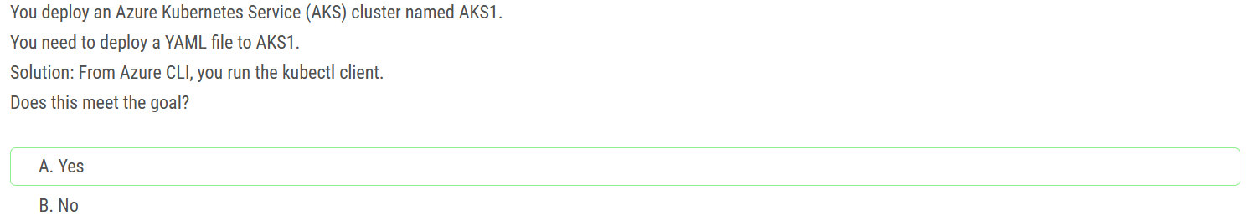

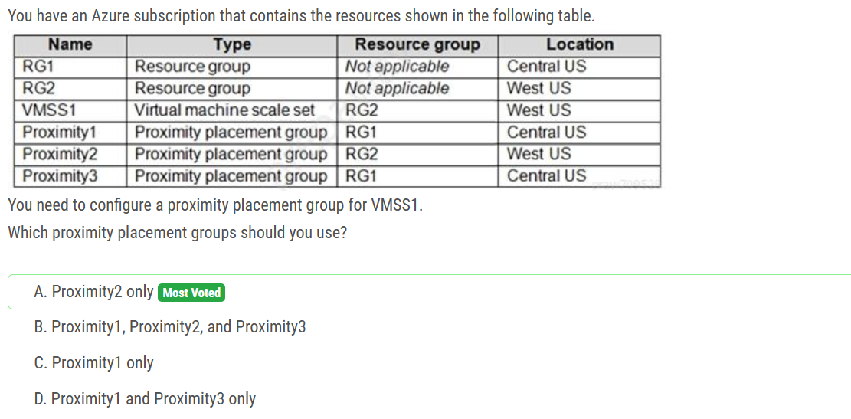

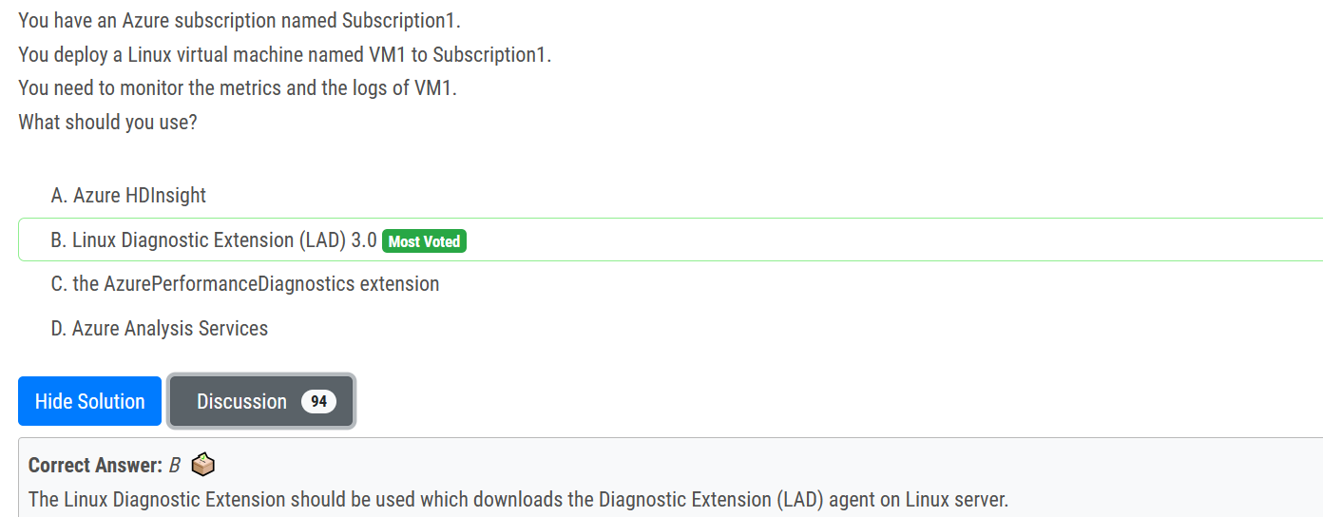

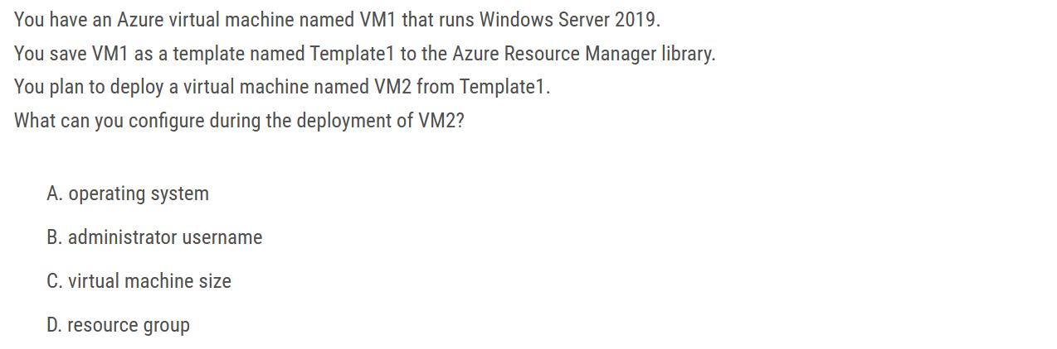

D. Resource Group is the correct answer: Admin user, password, vm size and os are the part of ARM templates. But resource group is not hence needs to be mentioned while deployment

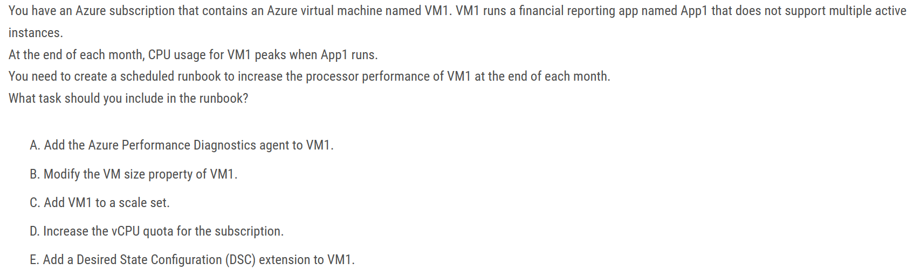

Correct Answer: B Here we need to modify the size of the VM to increase the number of vCPU's assigned to the VM. This can be included as a task in the runbook. The VM size property can be modified by a runbook that is triggered by metrics, but you can schedule it monthly.

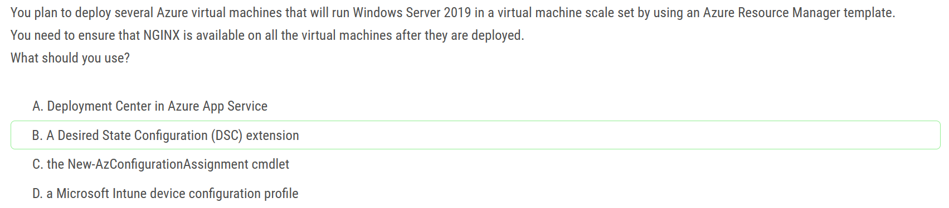

Note: There are several versions of this question in the exam. The question has two correct answers: 1. a Desired State Configuration (DSC) extension 2. Azure Custom Script Extension

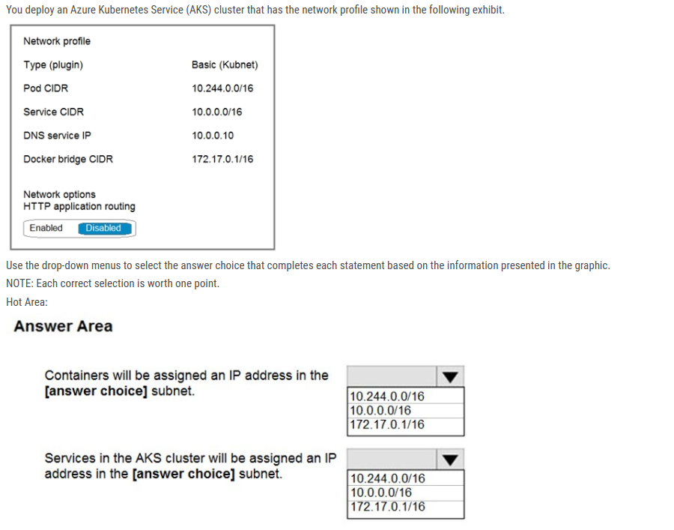

Box 1: 10.244.0.0/16 The Pod CIDR, because containers live inside Pods. Note: You can't change this address range once the cluster is deployed, if you need more addresses for additional nodes.

Box 2: 10.0.0.0/16 The Service CIDR is used to assign internal services in the AKS cluster an IP address.

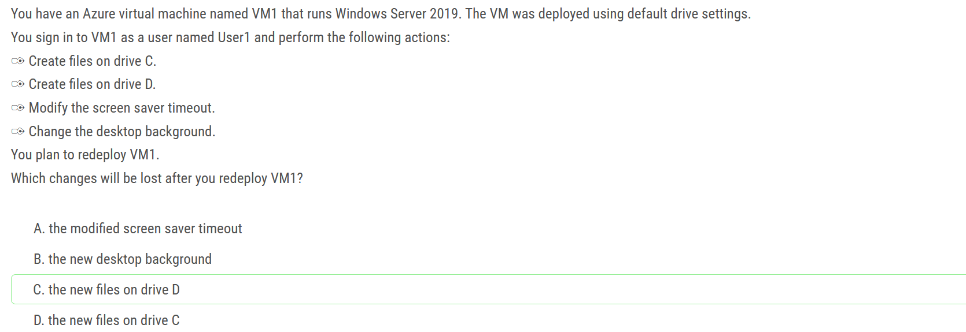

For Windows Server, the temporary disk is mounted as “D:\”.

For Linux based VM’s the temporary disk is mounted as “/dev/sdb1”.

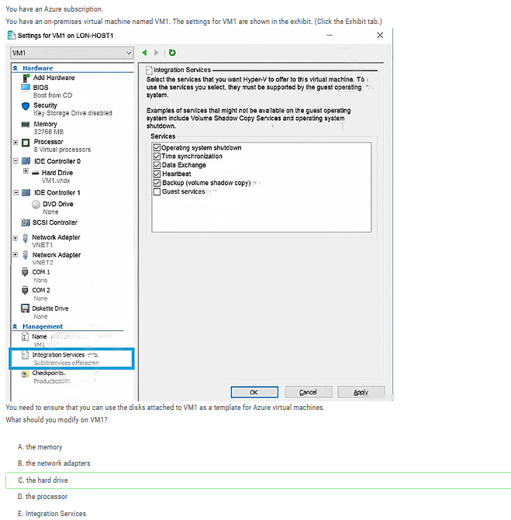

Before you upload a Windows virtual machine (VM) from on-premises to Azure, you must prepare the virtual hard disk (VHD or VHDX). Azure supports both generation 1 and generation 2 VMs that are in VHD file format and that have a fixed-size disk. The maximum size allowed for the OS VHD on a generation 1 VM is 2 TB.

You can convert a VHDX file to VHD, convert a dynamically expanding disk to a fixed-size disk, but you can't change a VM's generation

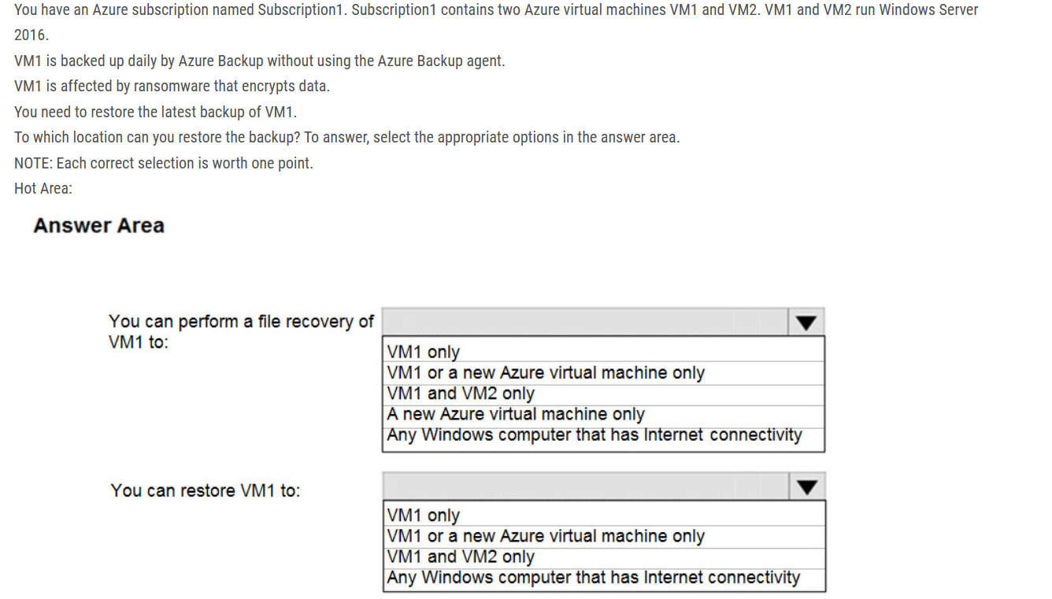

Box 1 = VM1 and VM2 Only "When recovering files, you can't restore files to a previous or future operating system version"

Box 2 = VM1 or a new Azure virtual machine only For restoring a VM, you can choose 'Create new' or 'Replace existing'.

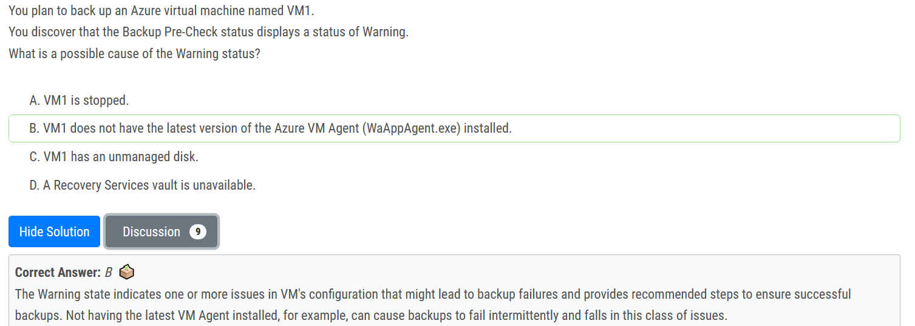

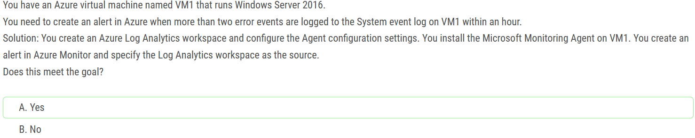

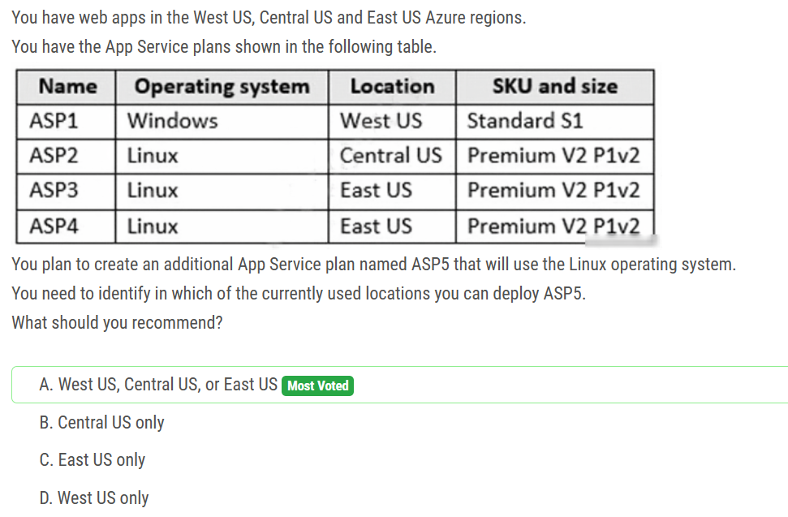

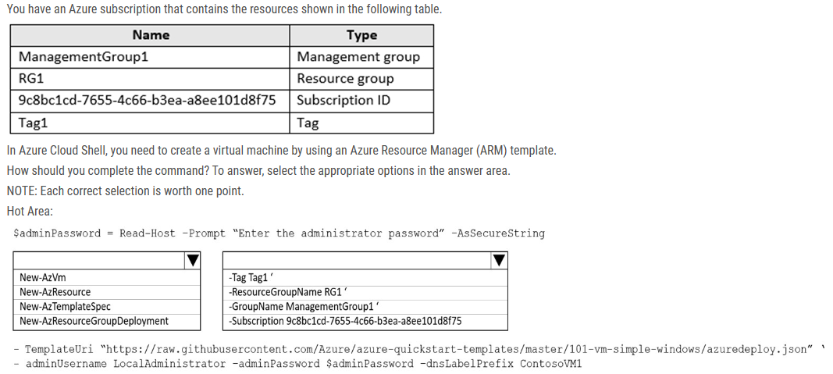

Box 1: New-AzResourceGroupDeployment. This cmdlet allows you to use a custom ARM template file to deploy resources to a resource group

Box 2: -ResourceGroupName RG1. It’s one of parameters of New-AzResourceGroupDeployment to specify to which resource group you want to deploy resources.

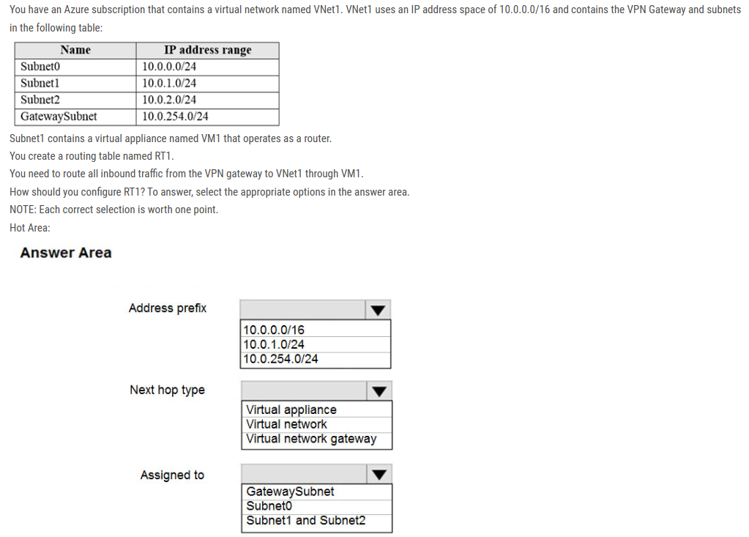

Box 1: 10.0.0.0/16 Address prefix destination-> Vnet 1 (Address space of Vnet1)

Box 2: Virtual appliance Next hop type VM1 ->Virtual Appliance. You can specify IP address of VM 1 when configuring next hop as Virtual appliance.

Box 3: Gateway Subnet Assigned to This route is to be followed by Gateway Subnet for the incoming traffic. You can associate routing table to the Subnet from Rout Table -> subnet ->Associate.

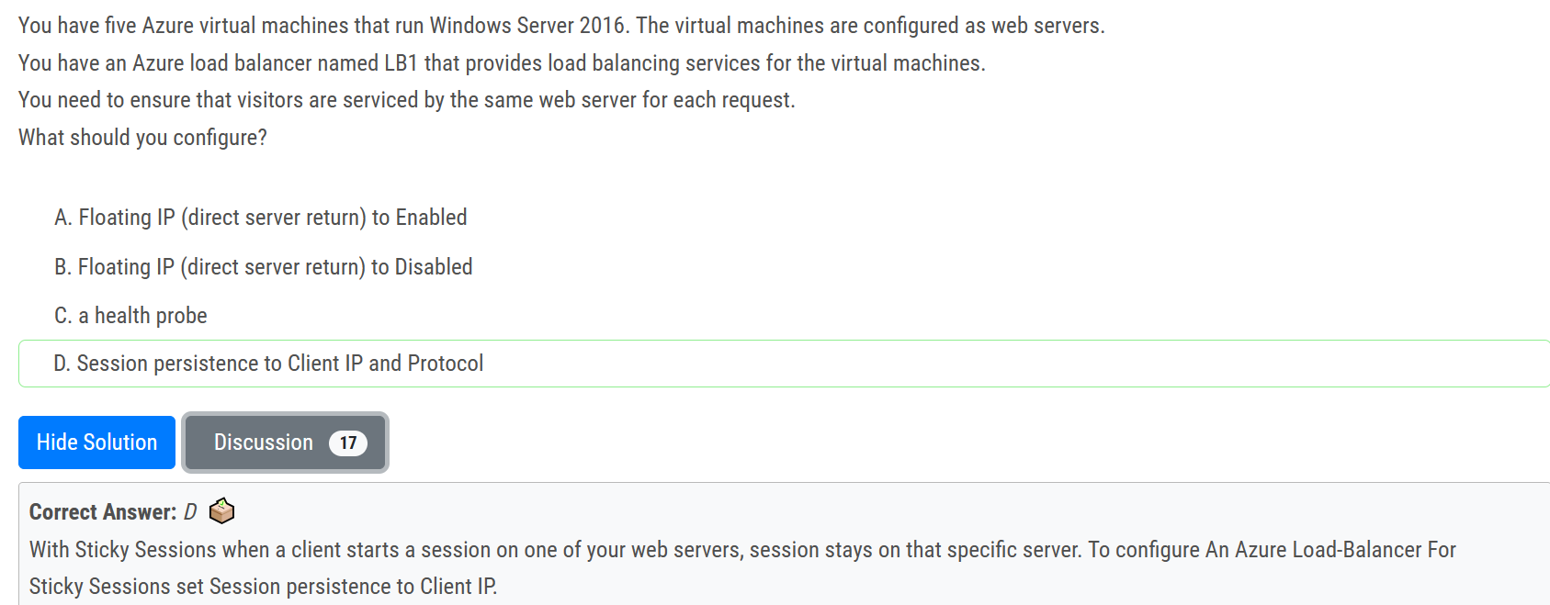

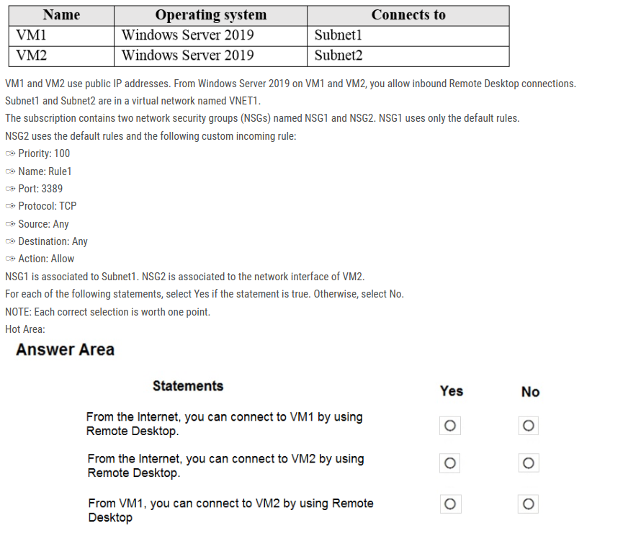

Answer is correct . No, Yes, Yes.

No: VM1 has default rules which denies any port open for inbound rules

Yes: VM2 has custom rule allowing RDP port

Yes: VM1 and VM2 are in the same Vnet. by default, communication are allowed

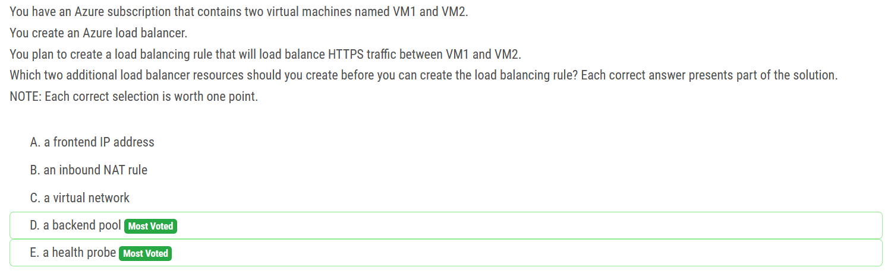

You can't create a LB without FrontEnd IP, so if we have a LB we also have a FrontEnd IP already. You can however create a LB without a backend pool and without any rules. If you want to add a rule to your LB later you have to create a backend pool and health probe first. Those are mandatory properties for a rule.

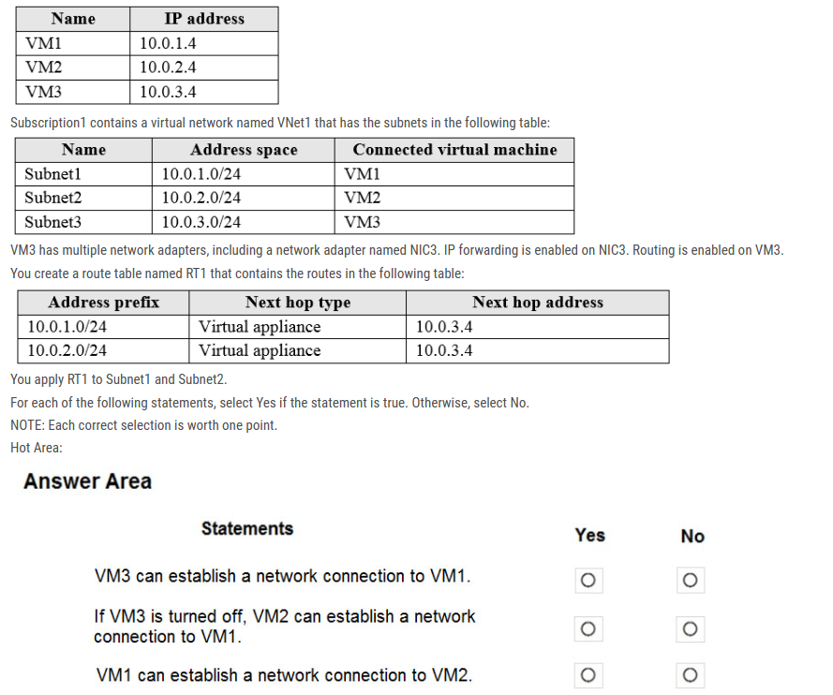

Box 1: Yes -  
The routing table allows connections from VM3 to VM1 and VM2. And as IP forwarding is enabled on VM3, VM3 can connect to VM1.  
  
Box 2: No -  
VM3, which has IP forwarding, must be turned on, in order for VM2 to connect to VM1.  
  
Box 3: Yes -  
The routing table allows connections from VM1 and VM2 to VM3. IP forwarding on VM3 allows VM1 to connect to VM2 via VM3.

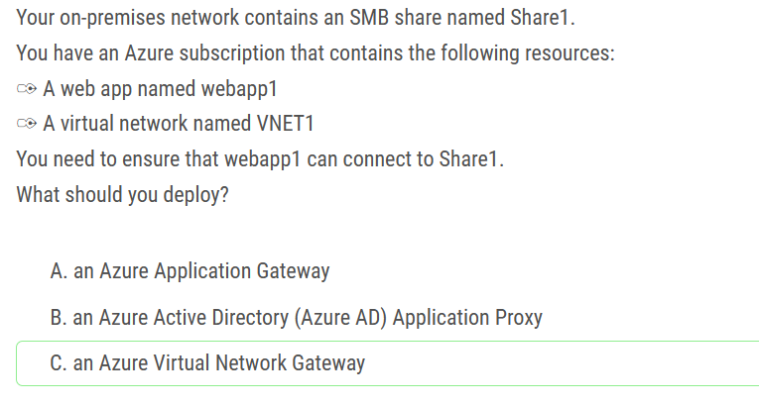

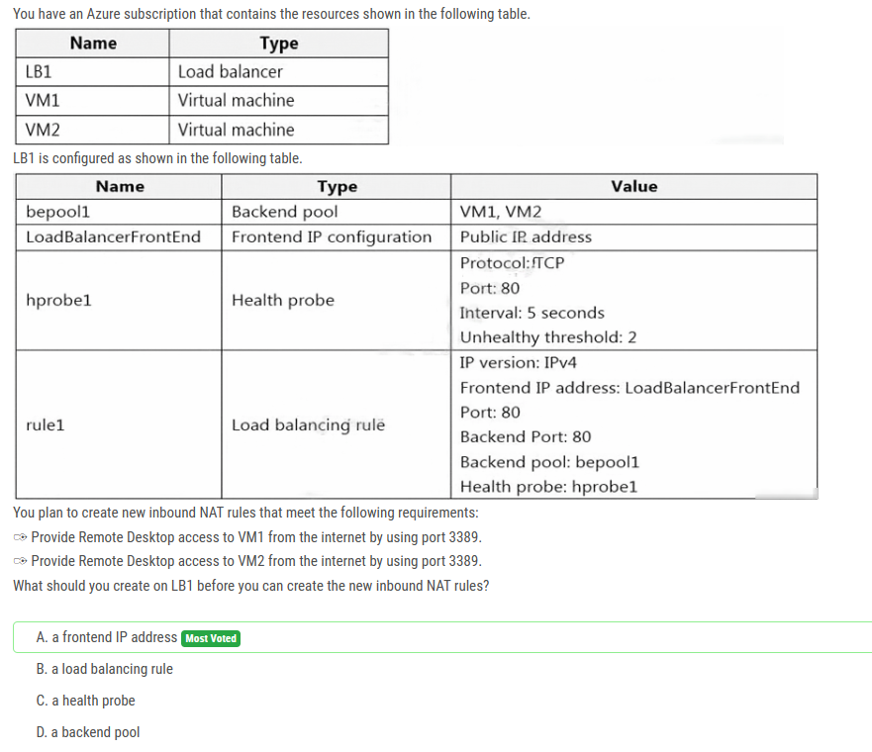

You can't use one single public IP & port combination to decidedly connect to two different systems based on readying your mind. Something has to tell the Firewall which VM you want to connect too. With the options provided, the only way is adding an additional frontend IP address. Hit one IP on 3389 you go to VM1 Hit the other IP on 3389 you go to VM2

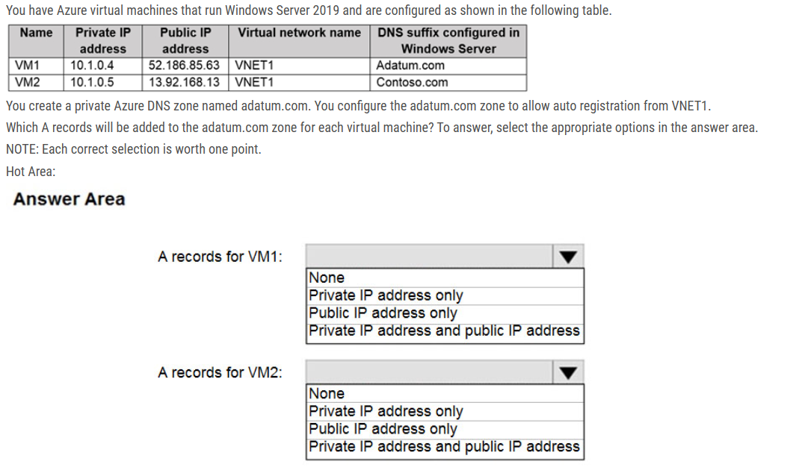

Box 1: Private

Box 2: Private

The virtual machines are registered (added) to the private zone as “A“ records pointing to their private IP addresses.

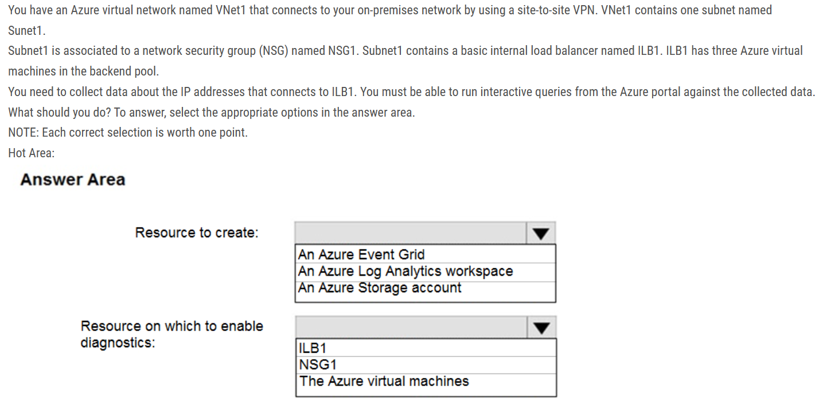

Box 1: An Azure Log Analytics workspace In the Azure portal you can set up a Log Analytics workspace, which is a unique Log Analytics environment with its own data repository, data sources, and solutions.

Box 2: NSG1 NSG flow logs allow viewing information about ingress and egress IP traffic through a Network security group. Through this, the IP addresses that connect to the ILB can be monitored when the diagnostics are enabled on a Network Security Group.

We cannot enable diagnostics on an internal load balancer to check for the IP addresses. As for Internal LB, it is basic one. Basic can only connect to storage account. Also, Basic LB has only activity logs, which doesn't include the connectivity workflow. So, we need to use NSG to meet the mentioned requirements.

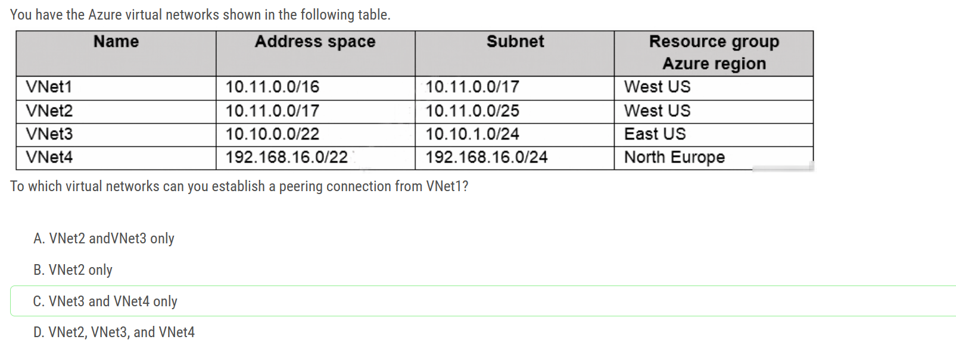

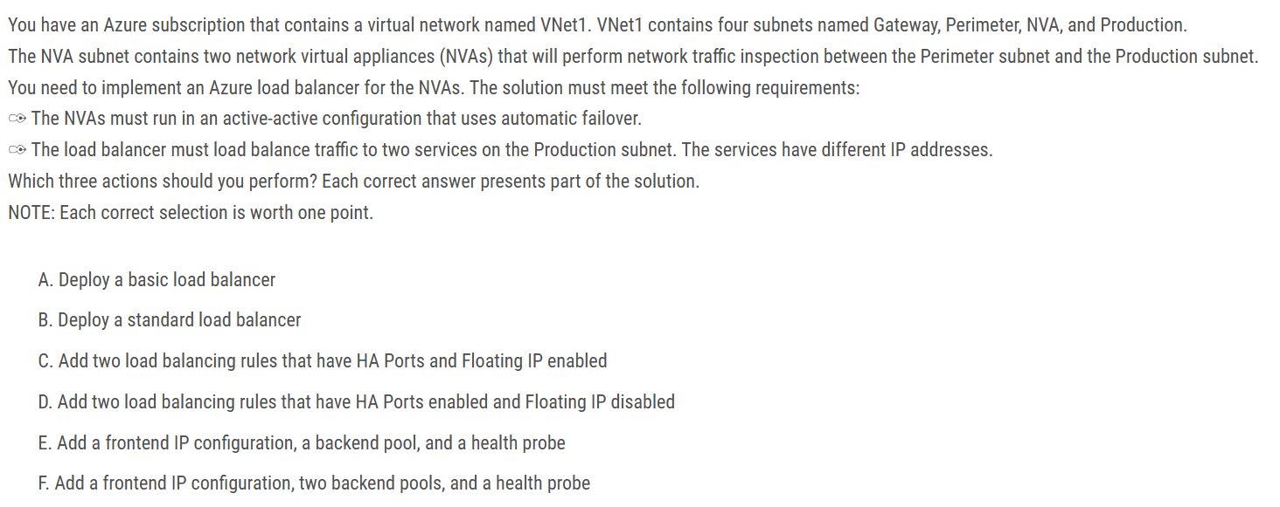

B: Deploy a standard load balancer HA ports need are not supported by a basic loadbalancer

C: Add two load balancing rules that have HA Ports and Floating IP enabled You need a floating ip for the active-active configuration to switch over quickly

F: Add a frontend IP configuration, two backend pools, and a health probe You need 2 backend pools for the 2 different services A standard load balancer is required for the HA ports. Two backend pools are needed as there are two services with different IP addresses. Floating IP rule is used where backend ports are reused.

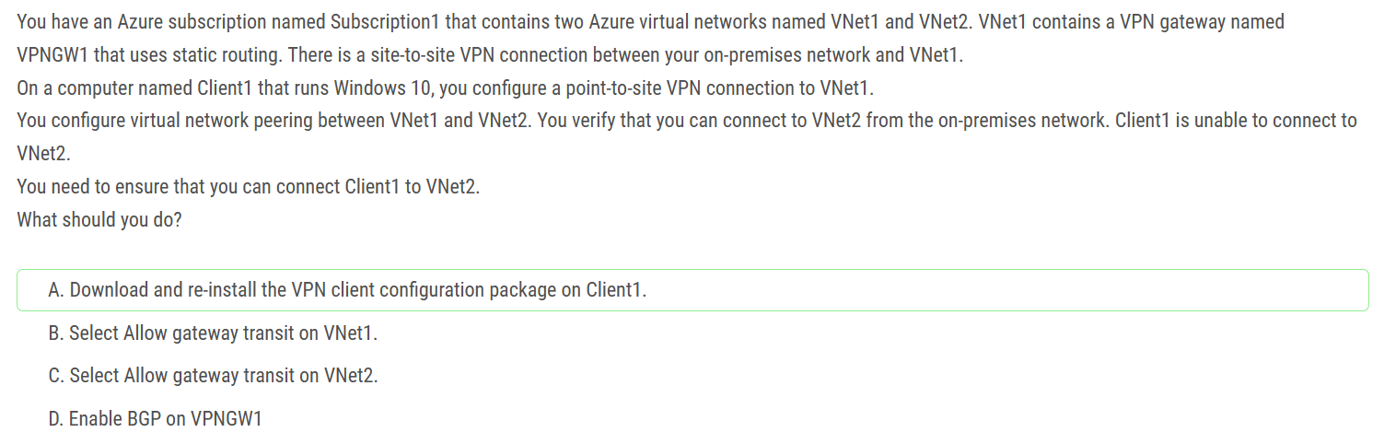

A is correct If you make a change to the topology of your network and have Windows VPN clients, the VPN client package for Windows clients must be downloaded and installed again and also ensure you use the same certificate and if other scenario i.e. new workstation Pt - Site vpn then download and install client and export certificate from other workstation that is already got working connection and import into new workstation

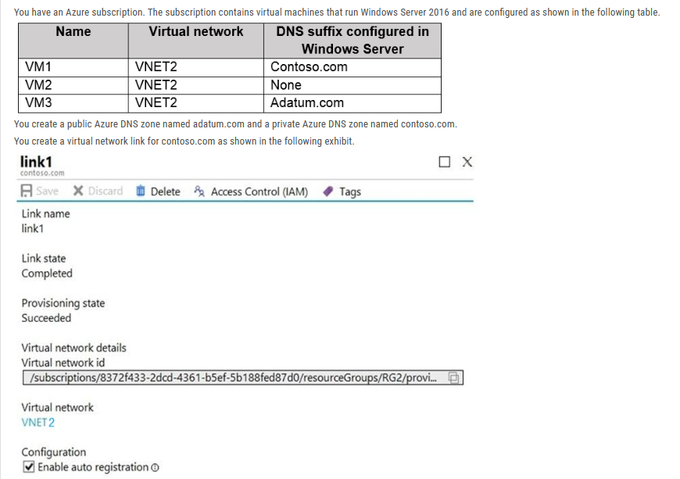

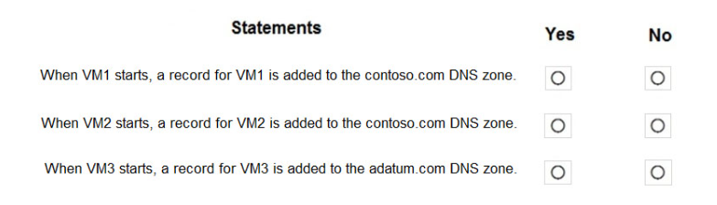

Ans: Yes, Yes, No

All three VMs are in VNET2. Auto registration is enabled for private Azure DNS zone named contoso.com, which is linked to VNET2. So, VM1, VM2 and VM3 will auto-register their host records to contoso.com.

None of the VMs will auto-register to a public DNS zone. You cannot register private IPs on the internet (adatum)

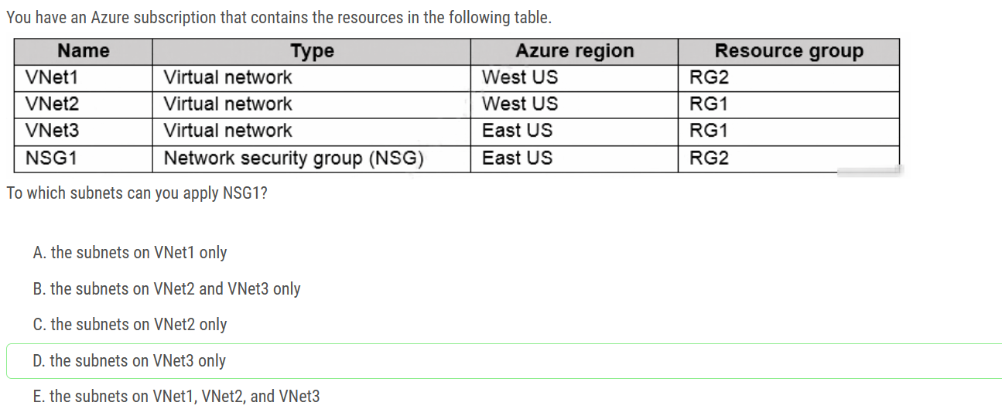

You can assign NSG to the Subnet of the VNet in the same region where NSG is. NSG1 is in East US and only VNet3 Subnets are in East US.

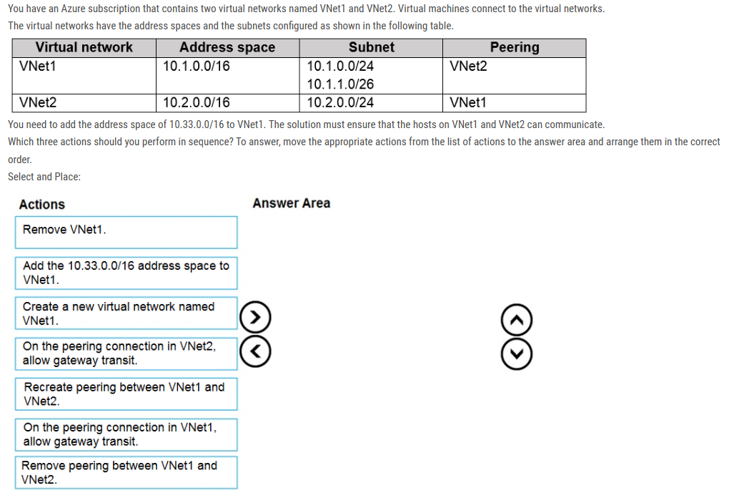

Step 1: Remove peering between Vnet1 and VNet2 You can't add address ranges to or delete address ranges from a virtual network's address space once a virtual network is peered with another virtual network. To add or remove address ranges, delete the peering, add or remove the address ranges, then re-create the peering.

Step 2: Add the 10.33.0.0/16 address space to VNet1

Step 3: Recreate peering between VNet1 and VNet2

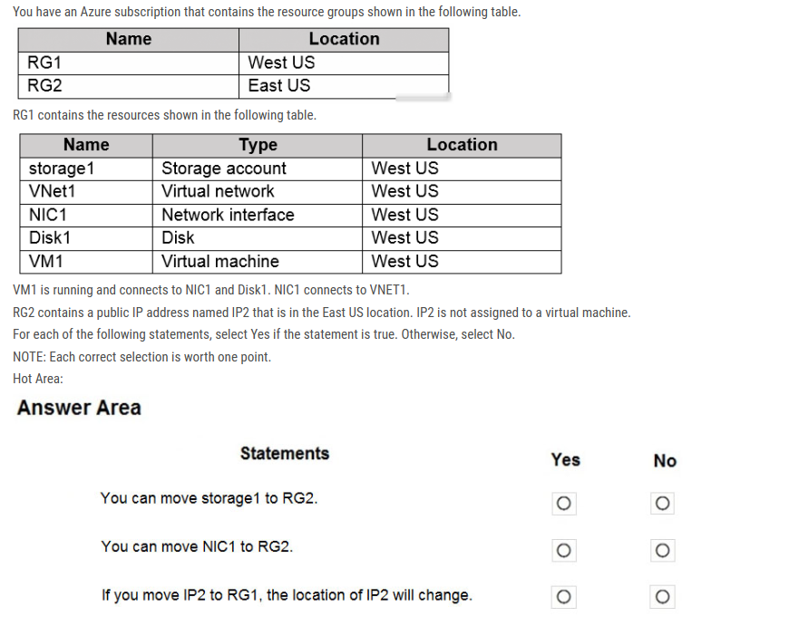

Box 1: Yes You can move the Storage Account to RG2, however it stayed in the West US region. You cannot change the Region, you need to recreate the Storage Account.

Box 2: Yes You can move move NIC1 to RG2 which was associated with VM1 and VNET1 subnet1, however it stayed in the West US region. You can move a NIC to a different RG or Subscription by selecting (change) next to the RG or Subscription name. If you move the NIC to a new Subscription, you must move all resources related to the NIC with it. If the network interface is attached to a virtual machine, for example, you must also move the virtual machine, and other virtual machine-related resources.

Box 3: No You can move IP2 to RG1, as it isn't associated with any other resource, however it stayed in the East US region. The location will not change.

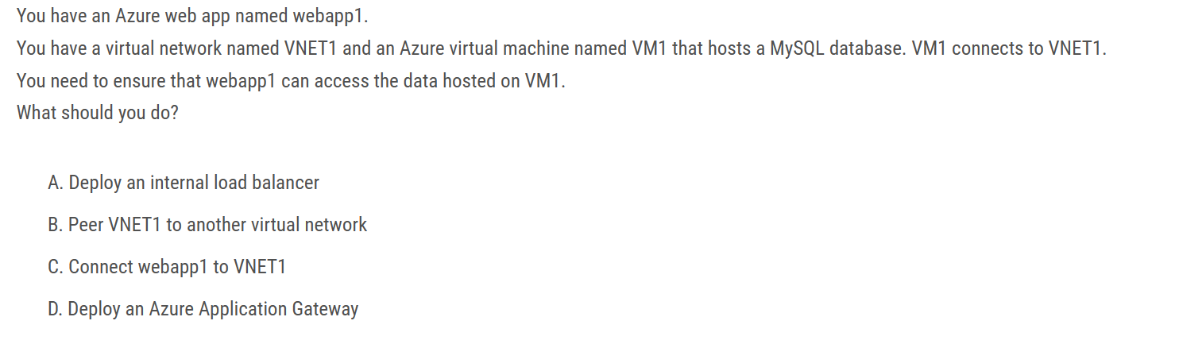

answer should be C , utilizing web app VNET integration.

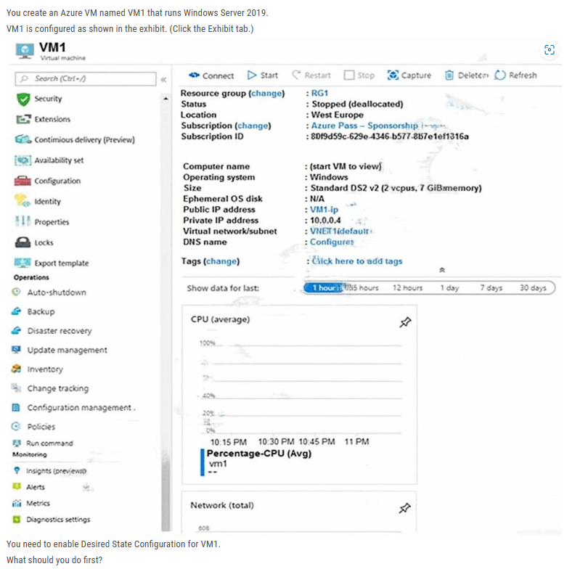

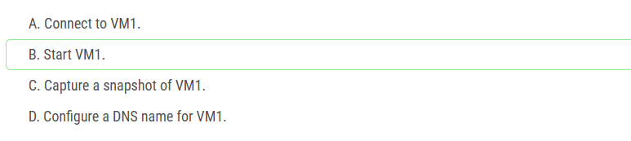

Status is Stopped (Deallocated).  
The DSC extension for Windows requires that the target virtual machine is able to communicate with Azure.  
The VM needs to be started.

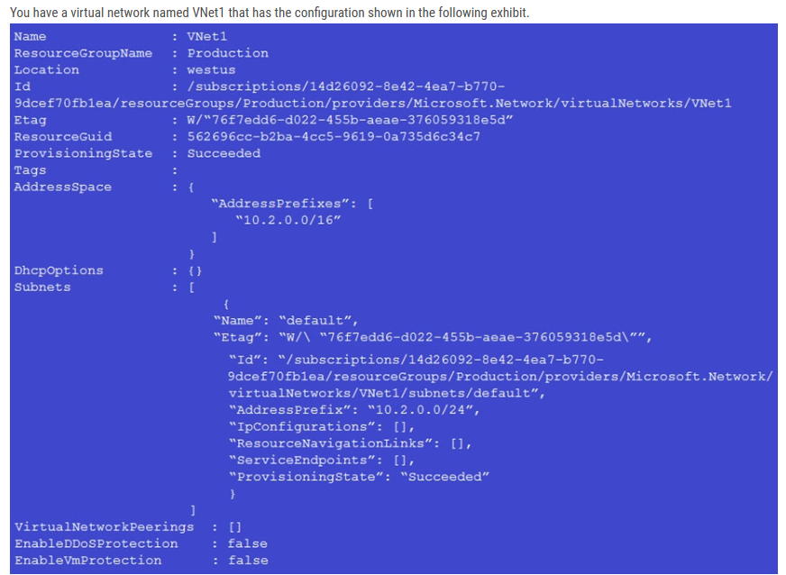

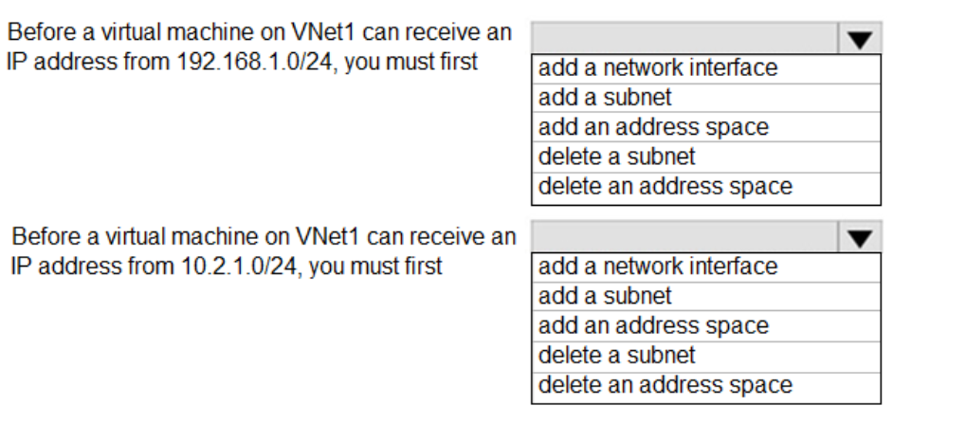

1: add an address space

2: add a subnet

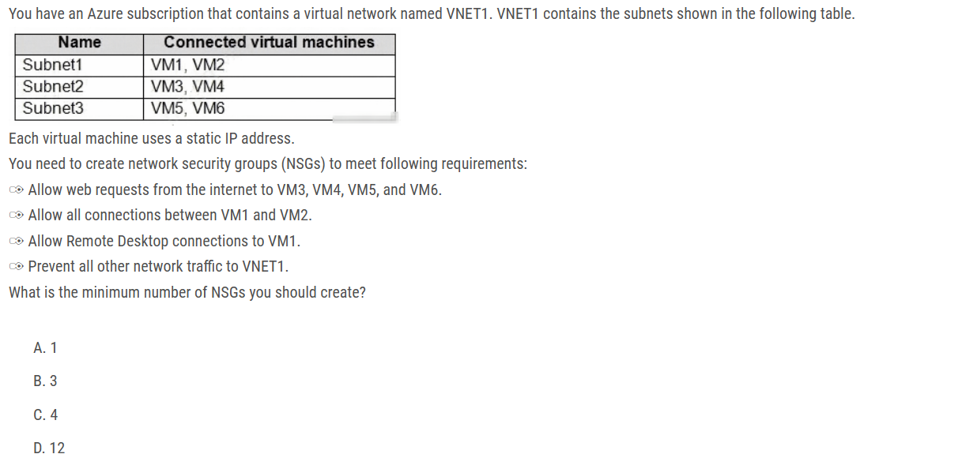

ans: A

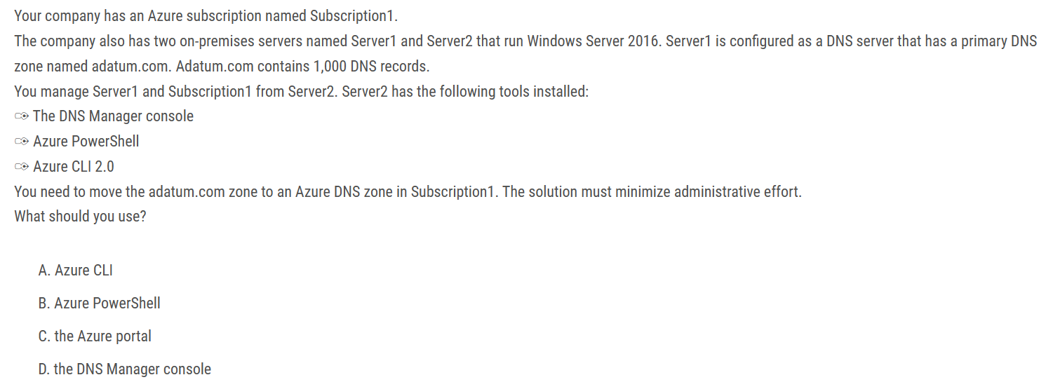

Ans: A

Azure DNS supports importing and exporting zone files via the Azure CLI. Importing zone files via Azure PowerShell or the Azure portal is **not** supported currently.

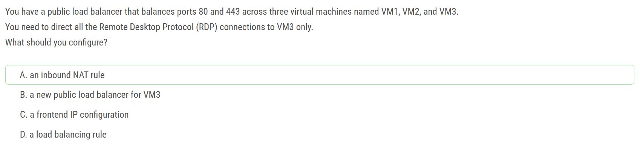

The difference between inbound NAT rules and port mapping in load balancer rules is that inbound NAT rules apply to direct forwarding to a VM, whereas load balancer rules forward traffic to a backend pool.

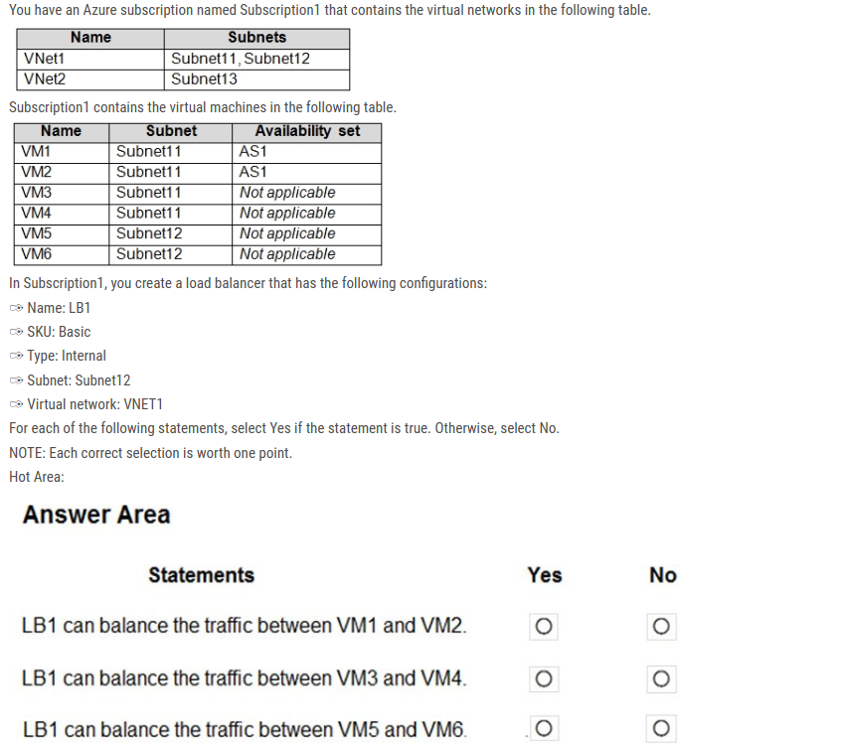

Box 1: Yes VM1 and VM are in the Availability Set.

Box 2: No Both VMs are not part of any Availability Set or Scale Set.

Box 3: No Both VMs are not part of any Availability Set or Scale Set.

The Basic Tier for load balancer is quite limiting. It can only have a single availability set, virtual machine scale set or a single machine. The Standard Tier can span any virtual machine in a single virtual network which includes blends of scale sets, availability sets, and machines."

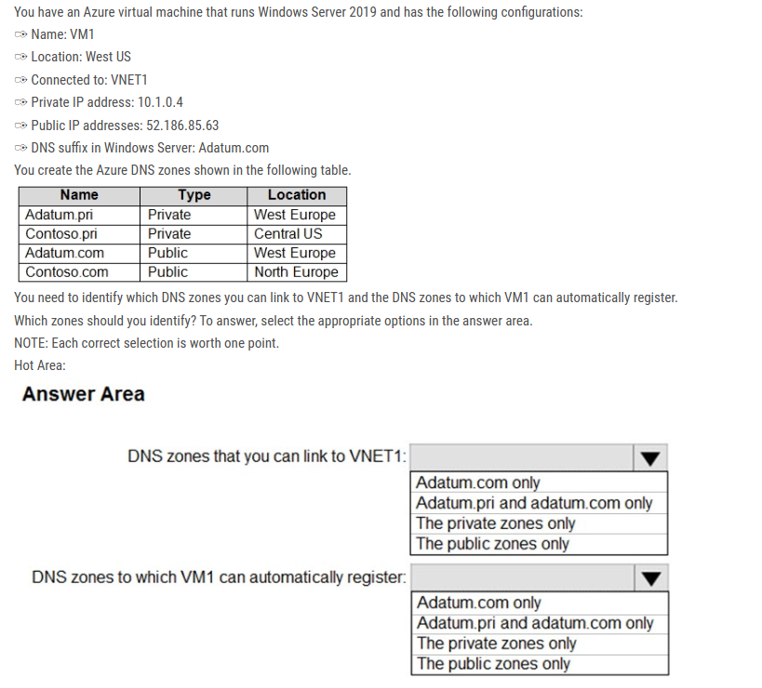

ans : Private zones only / Private zones only.

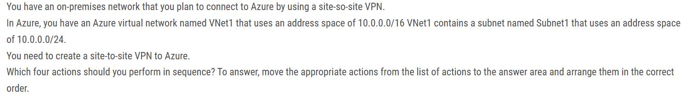

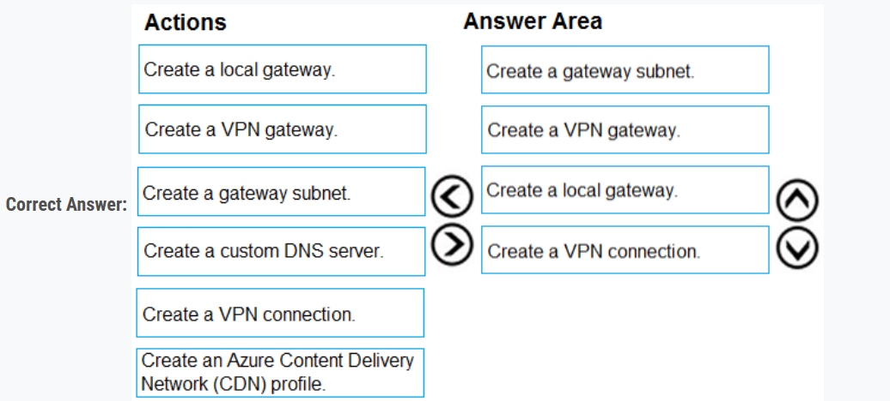

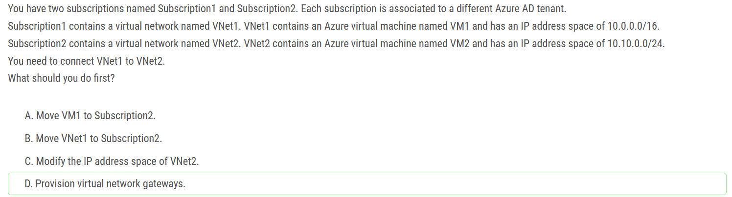

Correct Answer: D There is no overlap between the VNets:

VNet1: 10.0.0.0/16 - CIDR IP Range 10.0.0.0 - 10.0.255.255

VNet2: 10.10.0.0/24 - CIDR IP Range 10.10.0.0 - 10.0.0.255

You can connect virtual networks (VNets) by using the VNet-to-VNet connection type. Virtual networks can be in different regions and from different subscriptions. When you connect VNets from different subscriptions, the subscriptions don't need to be associated with the same Active Directory tenant.

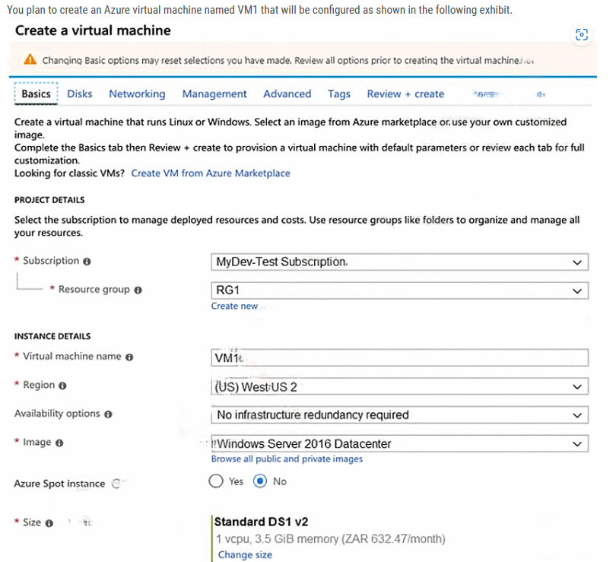

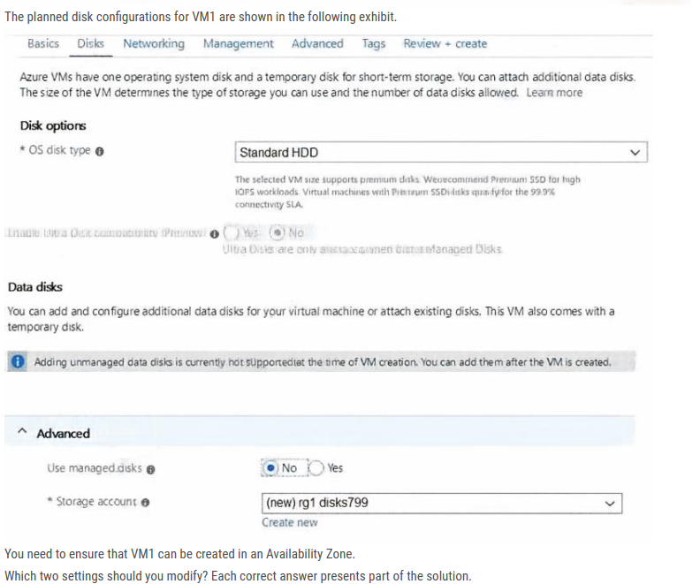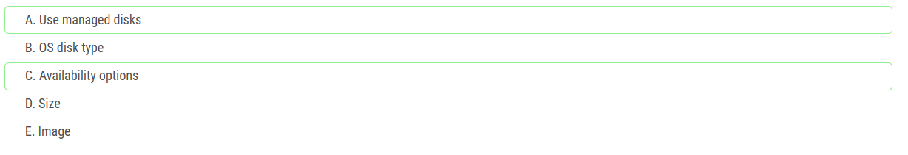

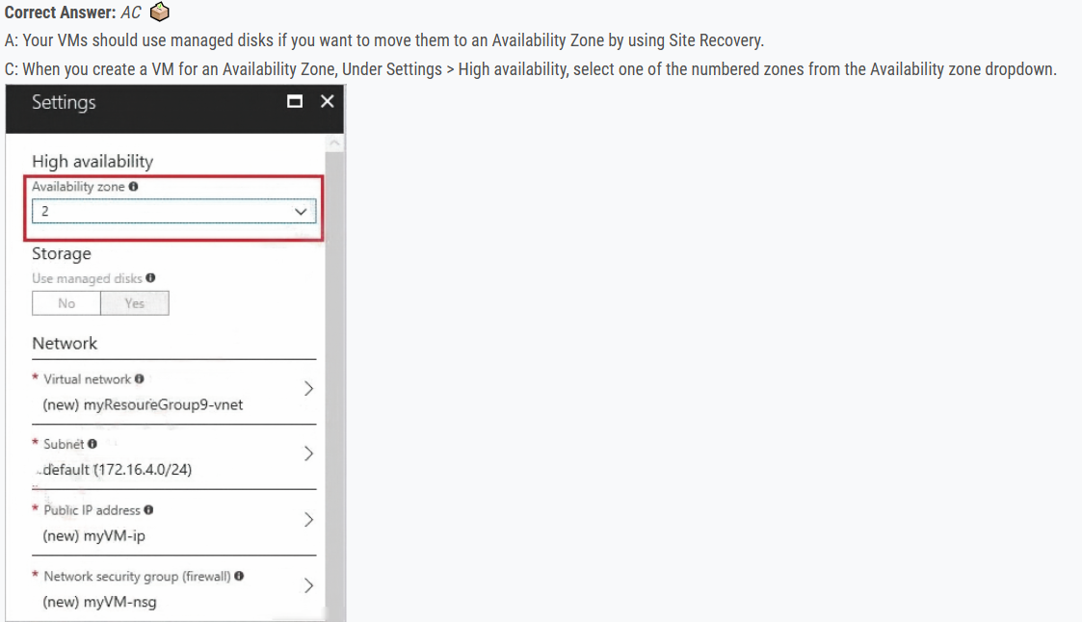

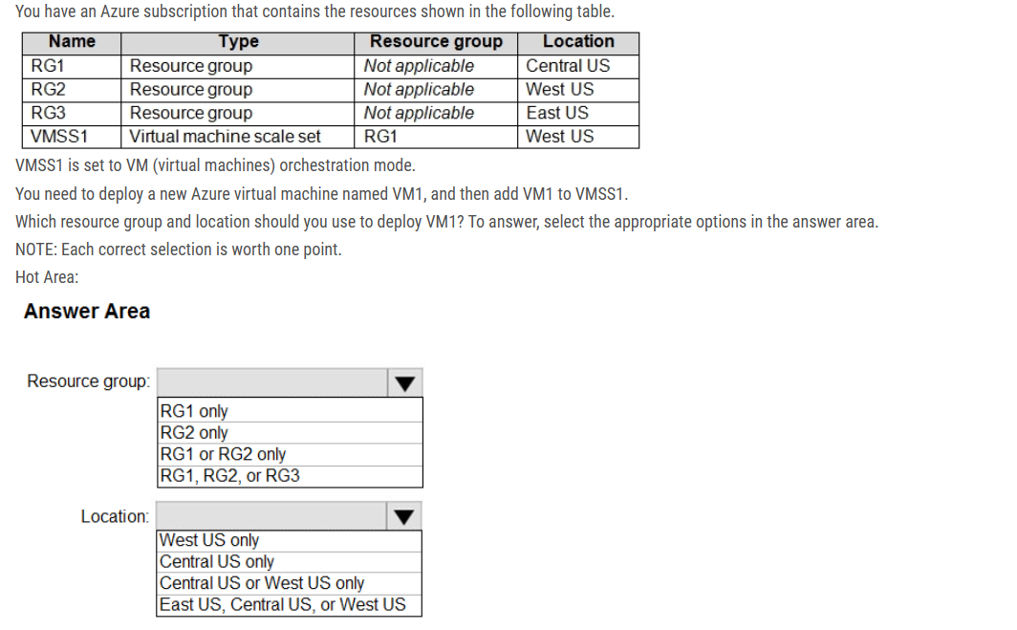

Resource group: RG1 only

Location: West US Only

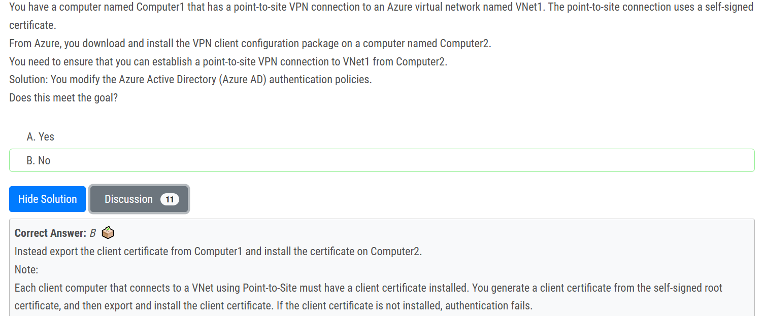

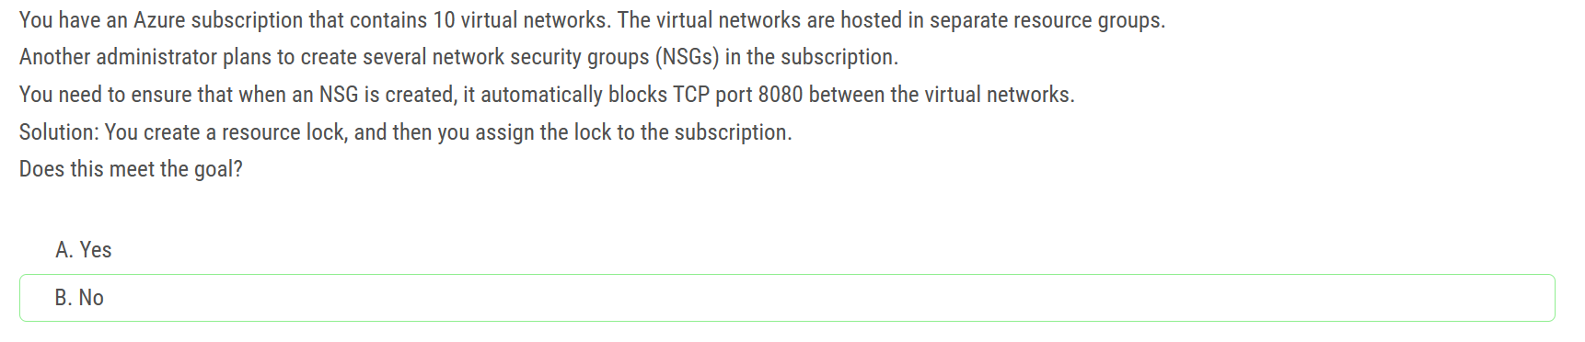

To achieve this goal, you can create an Azure Policy that enforces the required network security rule across all the virtual networks in the subscription. The policy should specify the rule that blocks TCP port 8080 traffic between the virtual networks. When a new NSG is created, it will automatically be associated with the policy, and the required network security rule will be enforced.

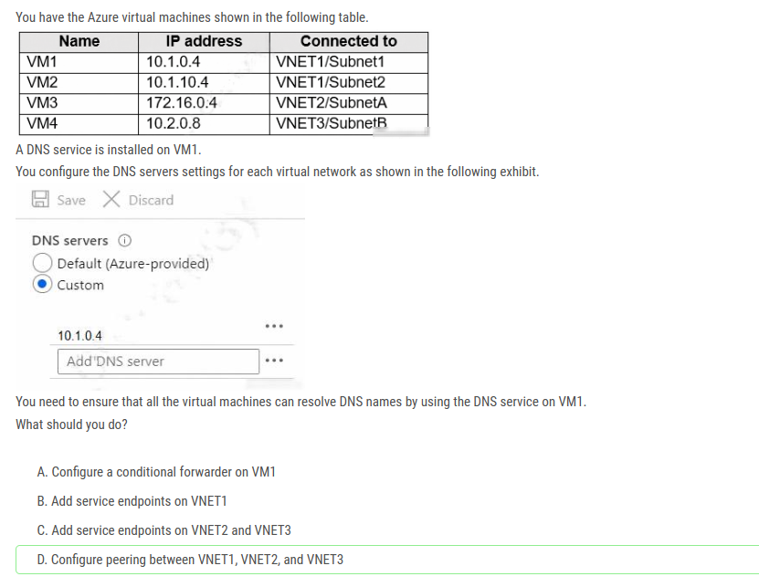

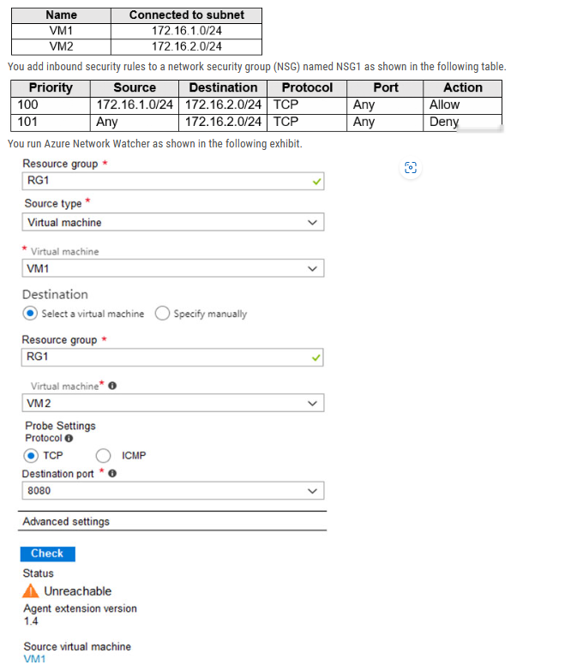

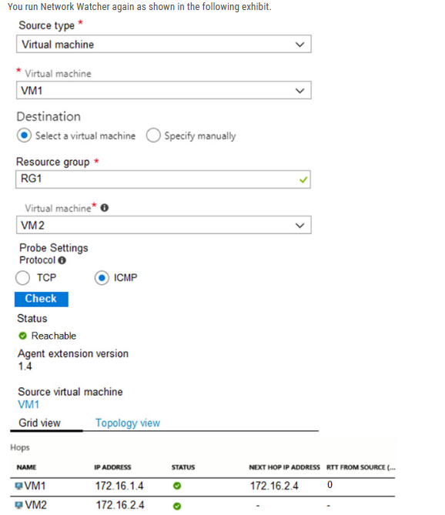

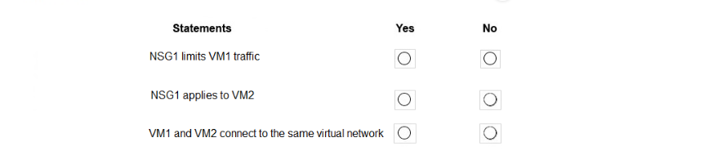

Box 1: No NSG1 limits the traffic that is flowing into 172.16.2.0/24 (Subnet2), which host VM2.

Box 2: Yes Since Network Watcher is showing that traffic from VM1 to VM2 is not reaching on the TCP port, that means that NSG1 is applied to VM2. We can understand for sure, that it is not applied to VM1.

Box 3: Yes In Network Watcher, you can see that the next hop is the destination VM2. This means that they are part of the same virtual network.

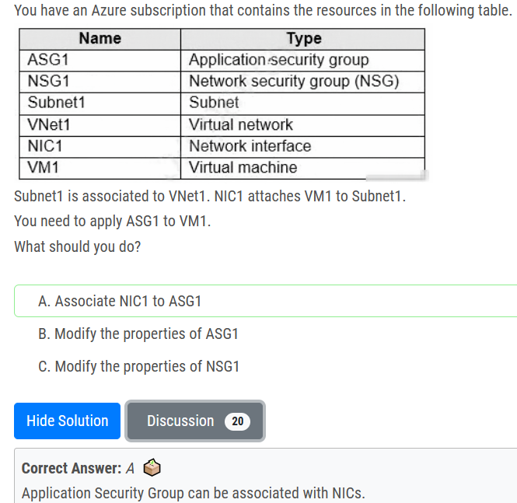

Application security groups enable you to configure network security as a natural extension of an application's structure, allowing you to group virtual machines and define network security policies based on those groups. You can reuse your security policy at scale without manual maintenance of explicit IP addresses. The platform handles the complexity of explicit IP addresses and multiple rule sets, allowing you to focus on your business logic.

You join virtual machines to the application security group, and then use the application security group as a source or destination in NSG rules.

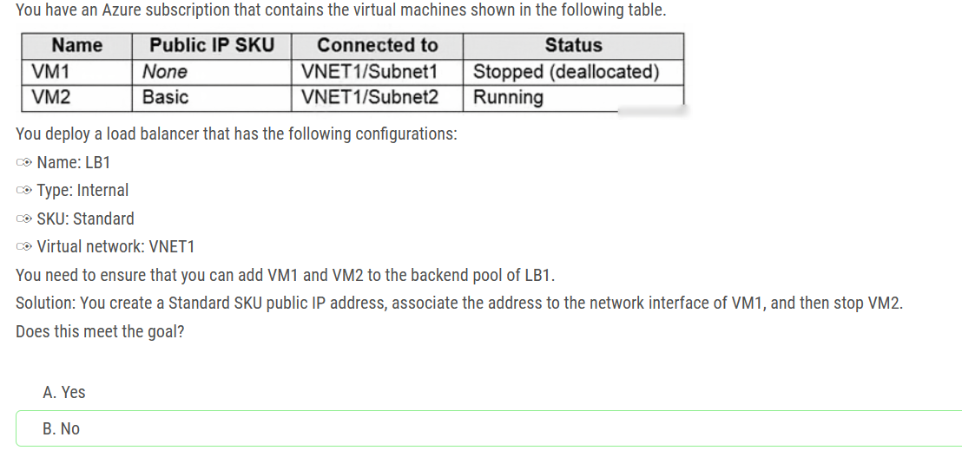

You can only attach virtual machines that are in the same location and on the same virtual network as the LB. Virtual machines must have a standard SKU public IP or no public IP. The LB needs to be a standard SKU to accept individual VMs outside an availability set or vmss. VMs do not need to have public IPs but if they do have them they have to be standard SKU. Vms can only be from a single network. When they don’t have a public IP they are assigned an ephemeral IP. Also, when adding them to a backend pool, it doesn’t matter in which status are the VMs.

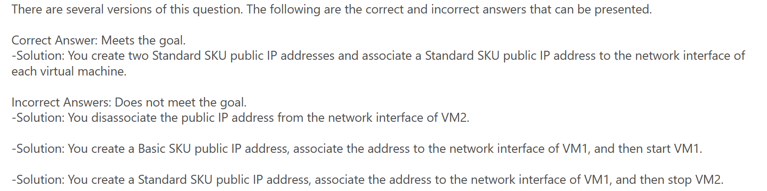

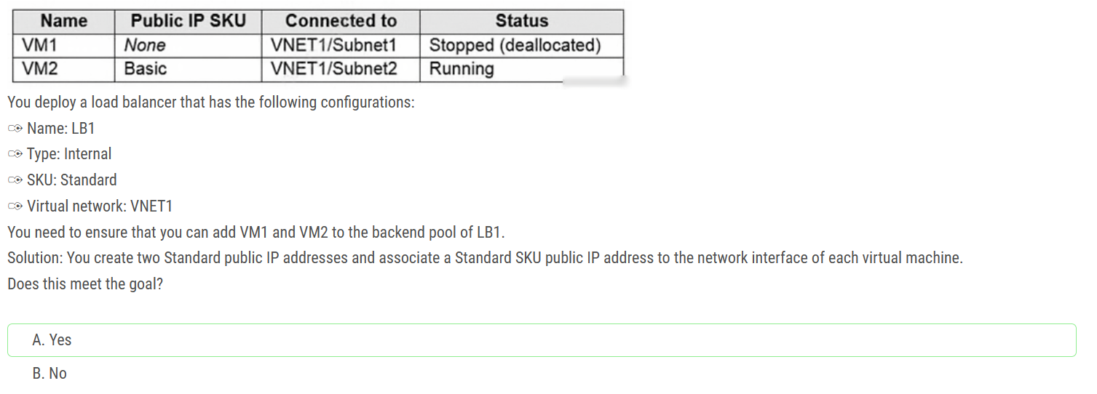

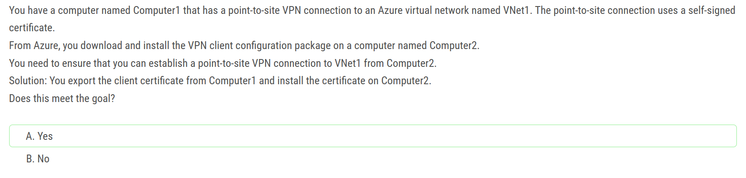

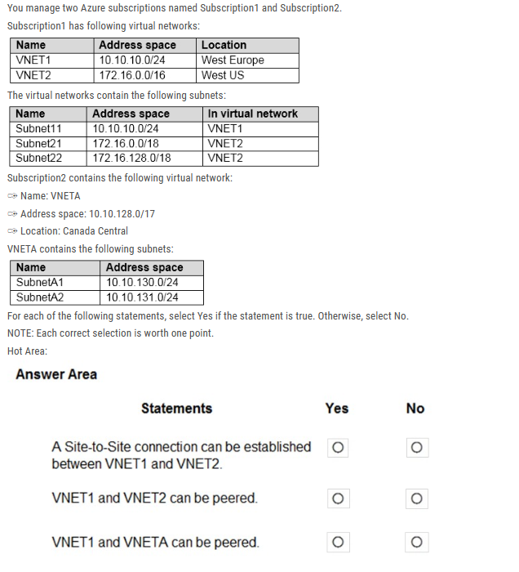

Box 1: No because to create a Vnet to Vnet VPN you need to have a special gateway subnet. Here the Vnet has only /24 CIDR blocks of address space and this space is already taken by its Subnet. Hence there is no sufficient address space to create a gateway subnet and thus to establish a Vnet to Vnet VPN connection.

Box 2: Yes For VNet peering the only consideration is that the VNets do not overlap. VNET1 and VNET2 do not overlap.

Box 3: Yes For VNet peering the only consideration is that the VNets do not overlap. VNET1 and VNETA do not overlap.

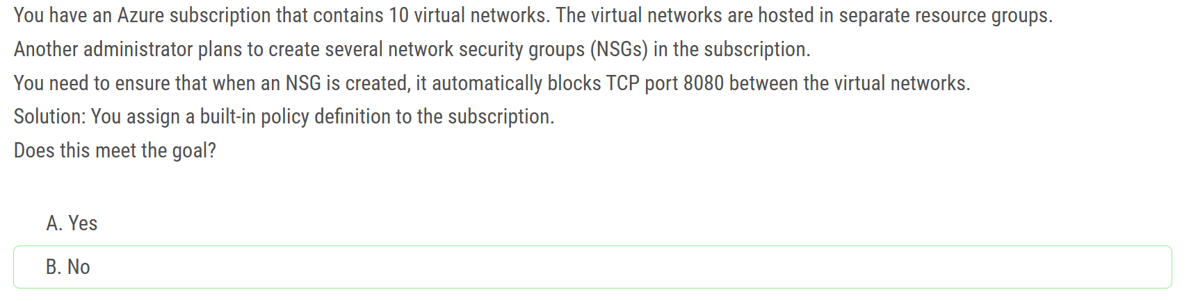

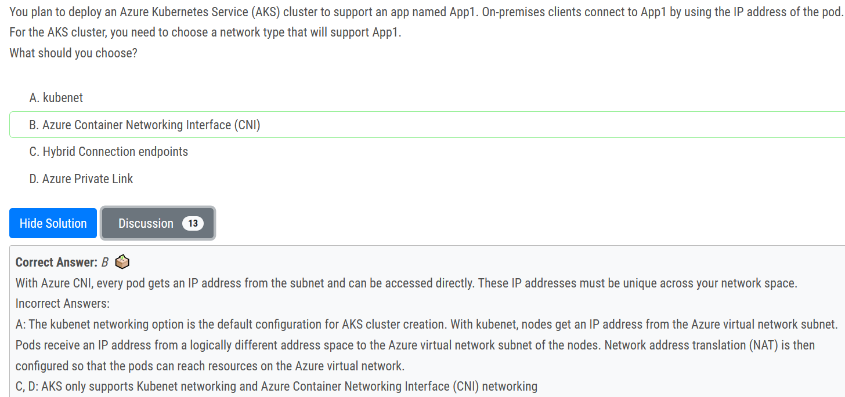

Nodes = Kubenete

Pods = CNI

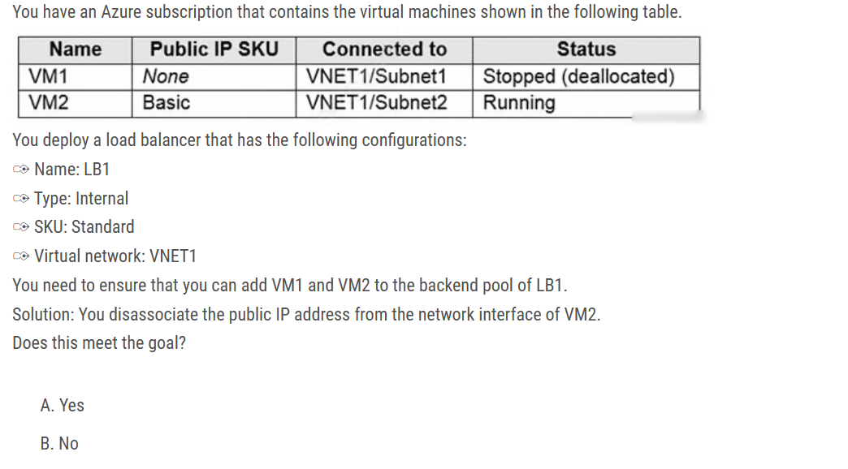

answer A (Yes)

You can only attach virtual machines that have a standard SKU public IP configuration or no public IP configuration. All IP configurations must be on the same virtual network. ALso, VMs do not have to be powered on when adding them to a backend pool.

Vms can only be from a single network. When they don’t have a public IP they are assigned an ephemeral IP.

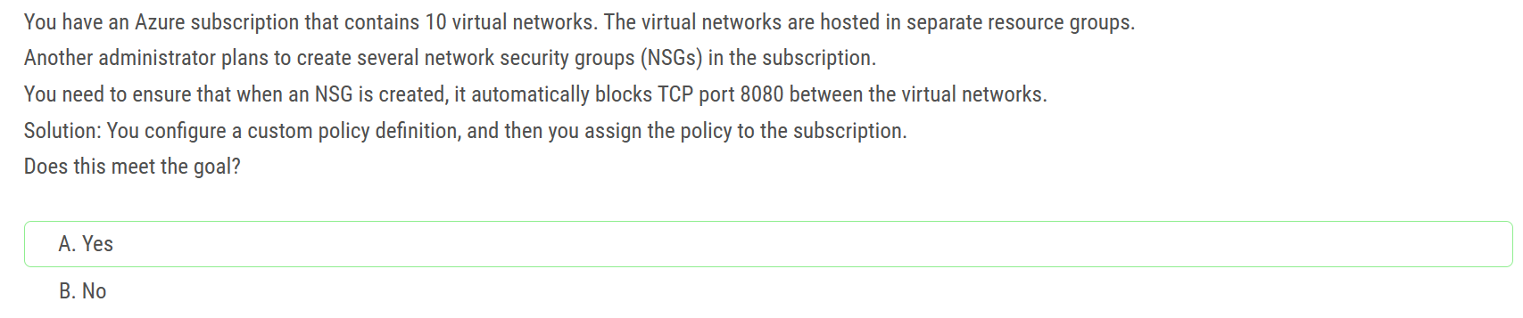

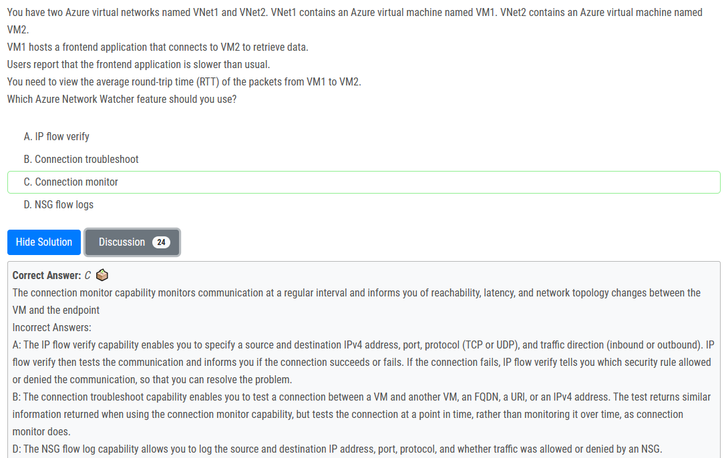

Connection monitor lets you know the round-trip time to make the connection, in milliseconds. Connection monitor probes the connection every 60 seconds, so you can monitor latency over time.

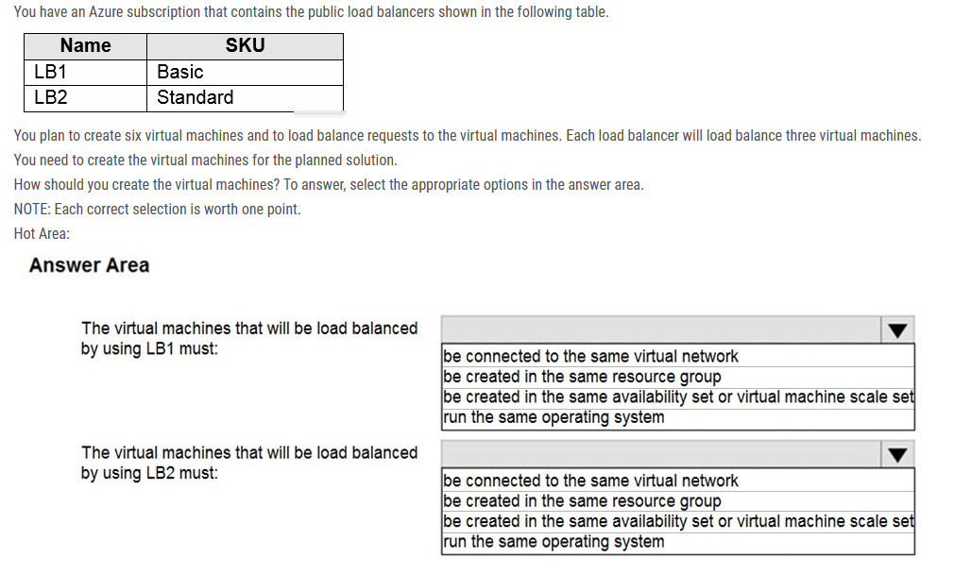

Box 1: be created in the same availability set or virtual machine scale set.  
The Basic tier is quite restrictive. A load balancer is restricted to a single availability set, virtual machine scale set, or a single machine.  
Box 2: be connected to the same virtual network  
The Standard tier can span any virtual machine in a single virtual network, including blends of scale sets, availability sets, and machines.

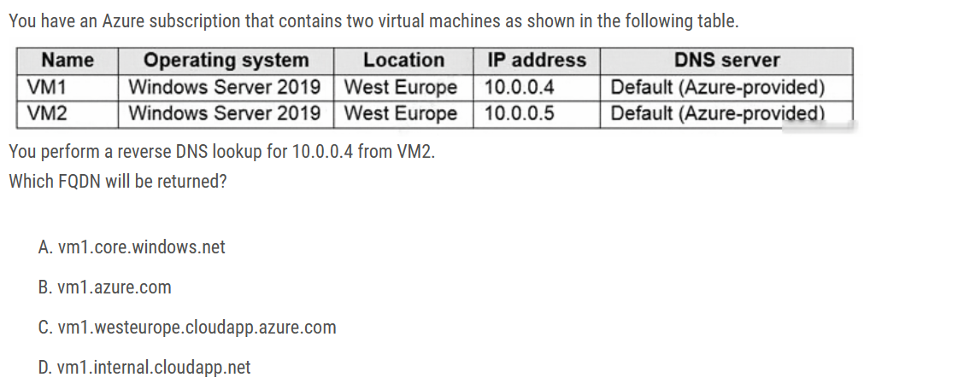

Ans : D

Reverse DNS for VMs is supported in all Azure Resource Manager based virtual networks. Azure-managed reverse DNS (PTR) records of form **[vmname].internal.cloudapp.net** are automatically added to when you start a VM, and removed when the VM is stopped (deallocated).

If an [Azure DNS private zone](https://learn.microsoft.com/en-us/azure/dns/private-dns-overview) is linked to the virtual network with a [virtual network link](https://learn.microsoft.com/en-us/azure/dns/private-dns-virtual-network-links) and [autoregistration](https://learn.microsoft.com/en-us/azure/dns/private-dns-autoregistration) is enabled on that link, then reverse DNS queries return two records. One record is of the form **[vmname].[privatednszonename]** and the other is of the form **[vmname].internal.cloudapp.net**.

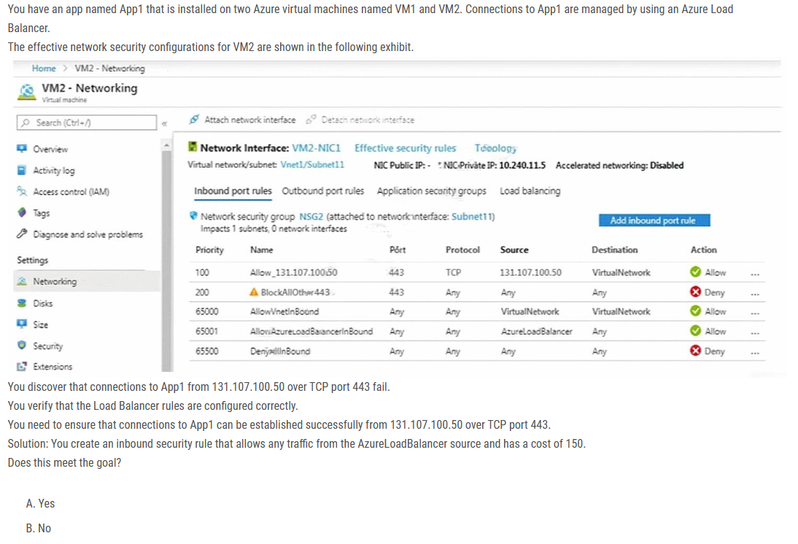

Ans: A

The rule with priority 200 blocks all inbound trafic. That involves the Azure Load Balancer health probe directed to the VM. That results in VM2 being considered unhealthy and the LB does not route traffic to it (hence the issue). By placing a rule with the priority 150 that allows the AzureLoadBalancer traffic tag, VM2 is discovered as functional/healthy, the LB directs traffic to it => problem solved.

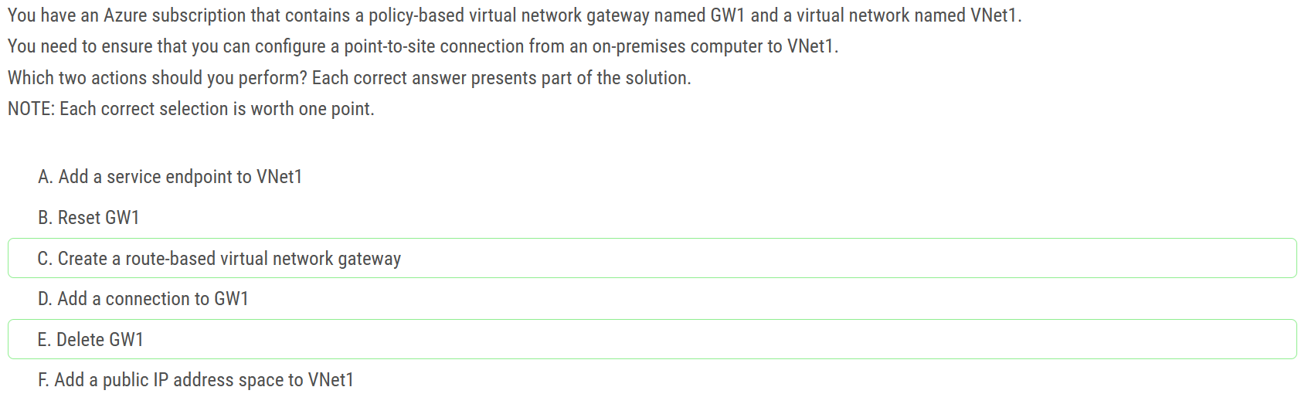

The VPN type you select must satisfy all the connection requirements for the solution you want to create. For example, if you want to create a S2S VPN gateway connection and a P2S VPN gateway connection for the same virtual network, you would use VPN type RouteBased because P2S requires a RouteBased VPN type

You can only use PolicyBased VPNs for S2S connections, and only for certain configurations. Most VPN Gateway configurations require a RouteBased VPN

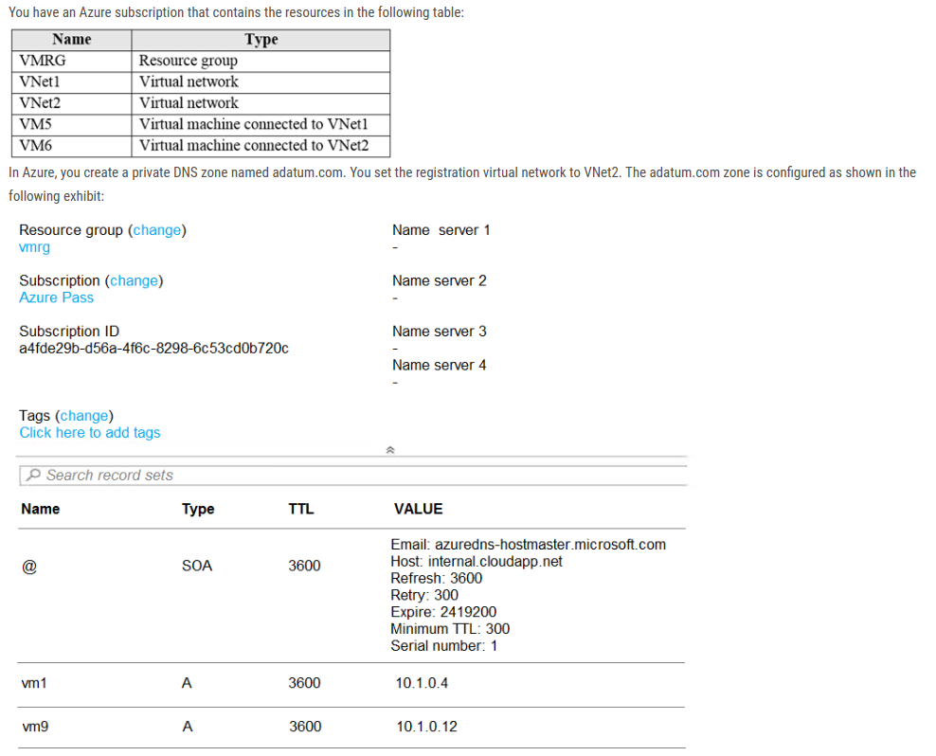

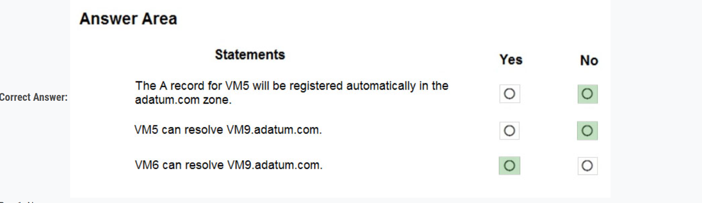

1. VM5 is in VNet1 - answer is NO.

2. VM5 is in VNet1 - answer is NO.

3. VM6 is in VNet2 - answer is YES.

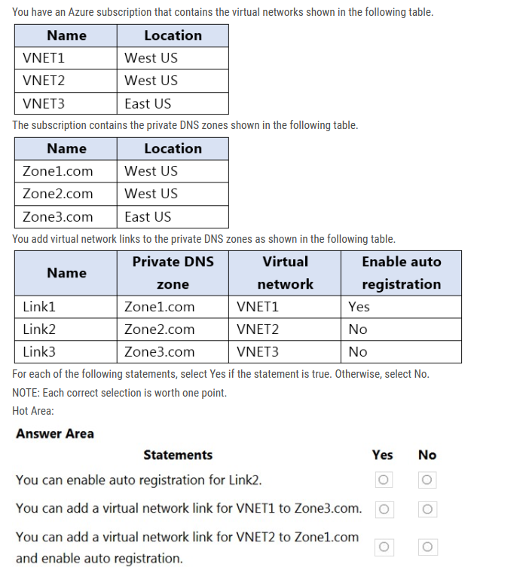

Number of private DNS zones a virtual network can get linked to with auto-registration enabled=1

Number of private DNS zones a virtual network can get linked=1000

Yes. Auto-registration can be enabled for Link2 because VNET2 is not currently a registration virtual network for any other private DNS zone. So it can become the registration virtual network for Zone2.com if auto-registration is enabled for Link2.

Yes. You can create a link between VNET1 and Zone3.com. However, because VNET1 is already a registration virtual network for Zone1.com, you cannot enable auto-registration for this new link. This is because "every virtual network can only have one registration zone associated with it."

No. You cannot enable auto-registration for this potential new link between VNET2 and Zone1.com because, as per the provided explanation, "every virtual network can only have one registration zone associated with it." Since VNET2 has already been linked to Zone2.com with auto-registration enabled (as per answer 1), it cannot become the registration virtual network for Zone1.com as well.

Not Sure about the last one

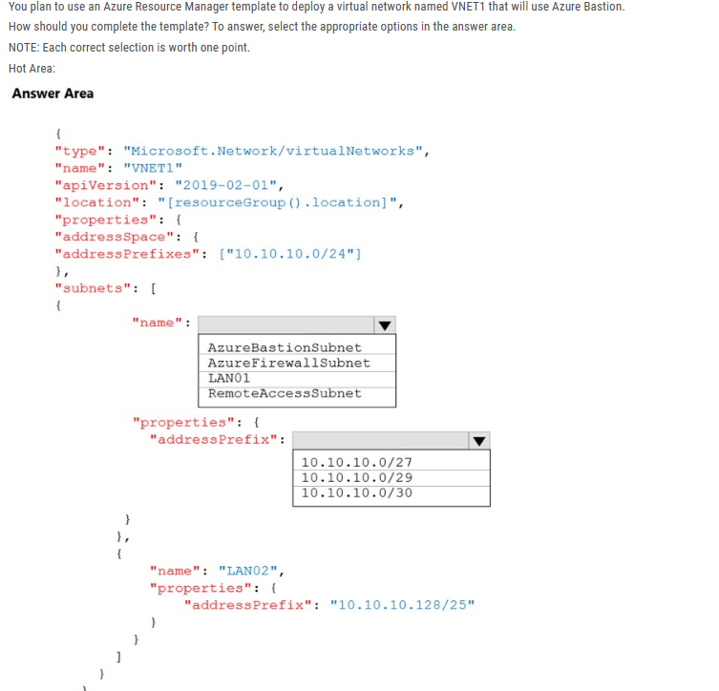

The question is outdated:

Azure Bastion requires a subnet called AzureBastionSubnet within your virtual network. The subnet must have at least the subnet mask /26, or be larger.

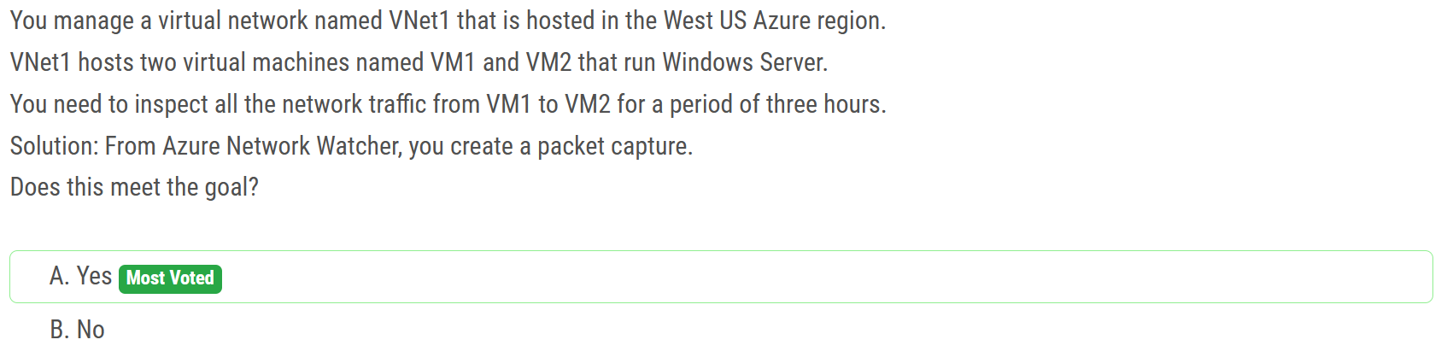

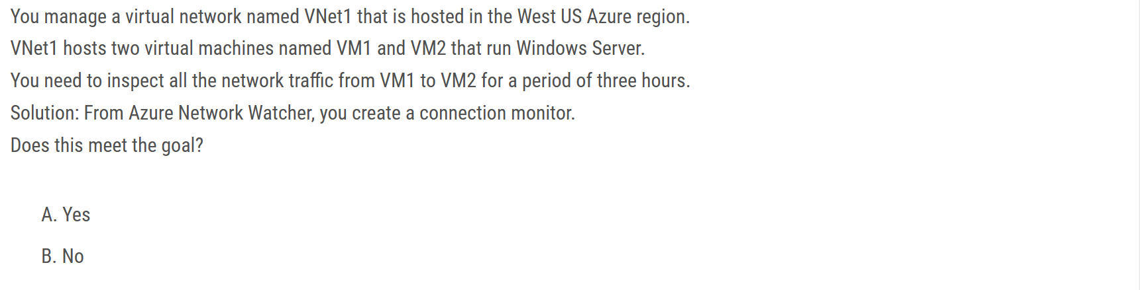

B. No

Creating a connection monitor in Azure Network Watcher will not meet the goal of inspecting all the network traffic from VM1 to VM2 for a period of three hours. Connection monitors in Azure Network Watcher are used to monitor the connectivity between two points in a network, but they do not capture and inspect the actual network traffic.

Even if we were using Connection monitor, this one would inspect only network traffic over a specific port.

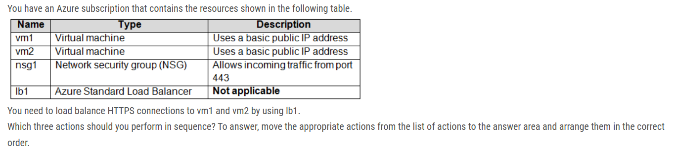

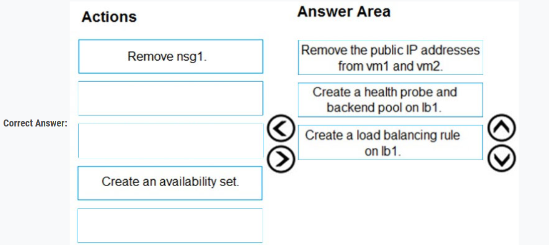

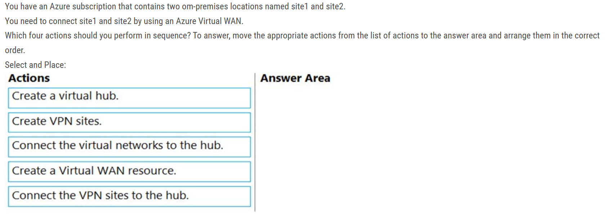

1. Create Azure Virtual WAN

2. Create Virtual Hub

3. Create VPN sites

4. Connect VPN sites to virtual hub

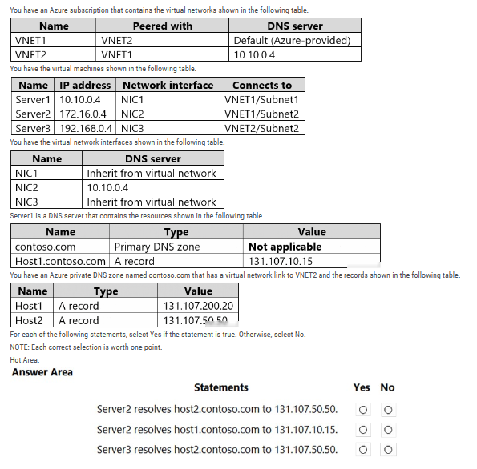

No: Server2 uses Server1 for DNS. Server1 has no host2.contoso.com record for 131.107.50.50. It would work if VNET1 hat a virtual network link to the private zone contoso.com.

Yes: Server2 uses Server1 for DNS. Server1 has a host1.contoso.com record for 131.107.10.15

No: Server3 uses 10.10.0.4 as DNS (inherited from VNET2). 10.10.0.4 (Server1) has no record for host2.contoso.com. The virtual network link for the private zone contoso.com on VNET2 won't be used since the DNS from VNET1 is set on VNET2. VNET1 DNS is not aware of the private zone contoso.com. It would work if VNET1 had a virtual network link to the private zone contoso.com.

NIC configured DNS takes precedence over VNET configured DNS.

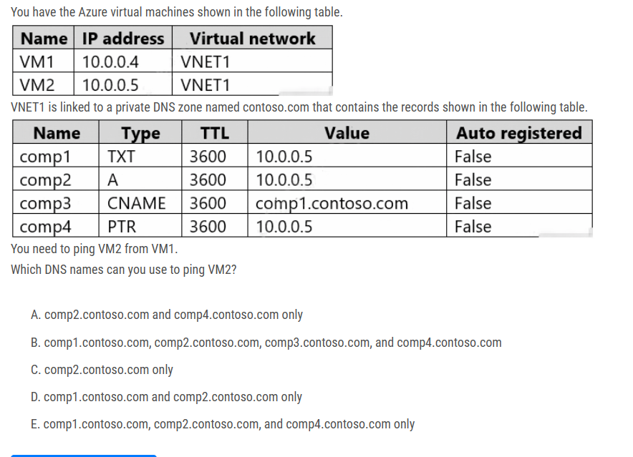

Correct Answer C:

comp2.contoso.com only A record: Is used to map a DNS/domain name to an IP

TXT records in a lot of cases get used to prove ownership of a domain, it has other purposes too.

PTR: A Reverse DNS lookup is used by remote hosts to determine who 'owns' an IP address.

CNAME records get used to redirect a DNS name or subdomain name to another DNS name or domain name or subdomain name.

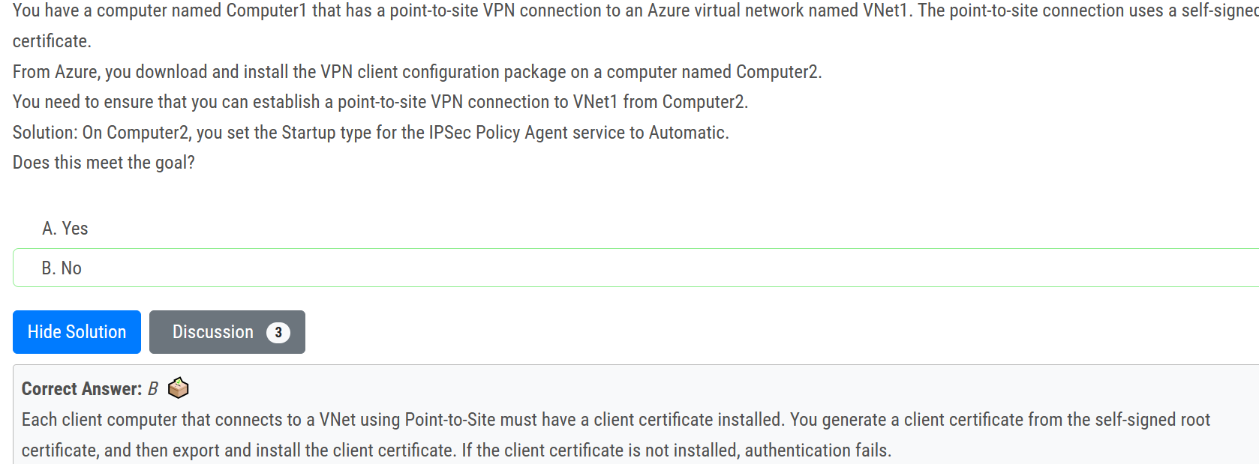

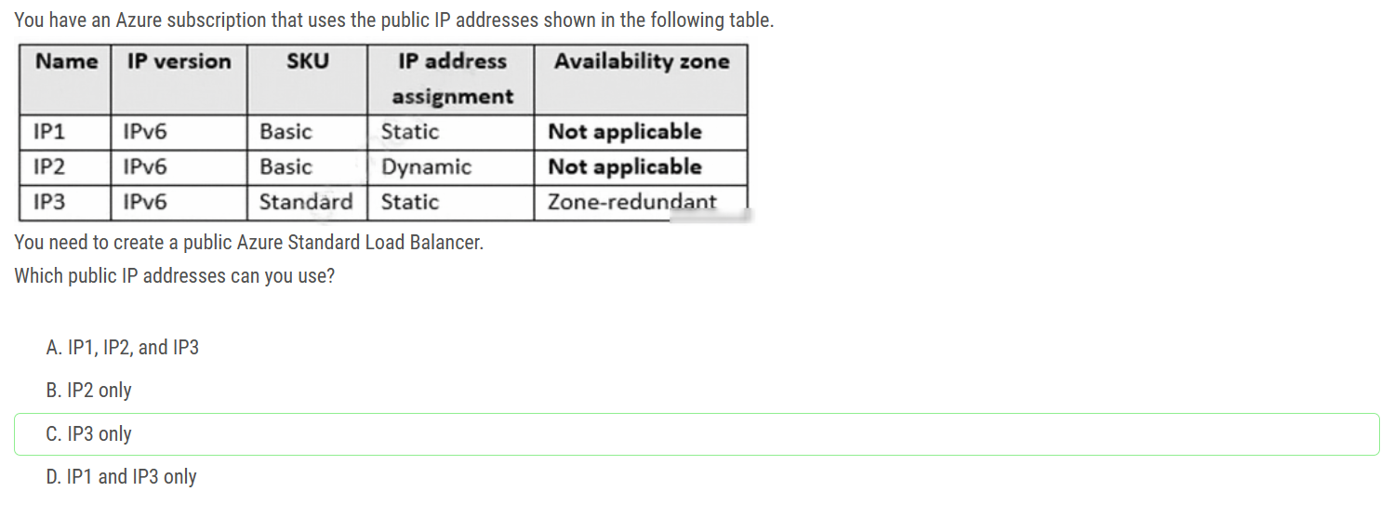

* Standard tier load balancers can only target Standard SKU IPs
* Basic tier load balancers can only target Basic SKU IPs

Matching SKUs are required for load balancer and public IP resources. You can't have a mixture of Basic SKU resources and standard SKU resources.  
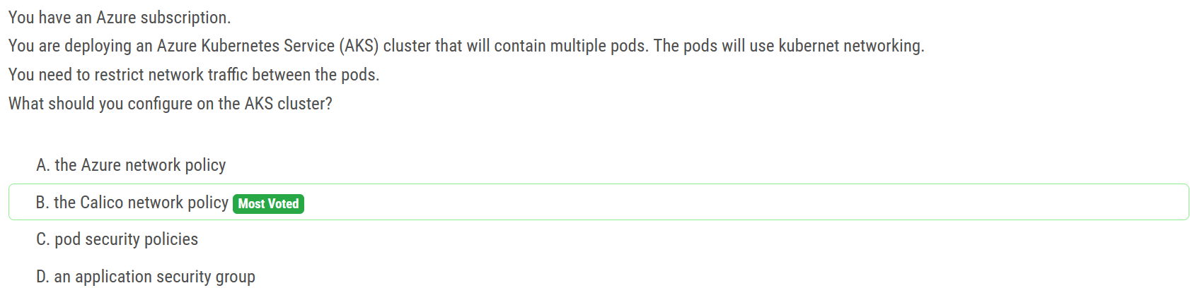

The question describes “the pods will use kubernet networking.” To provide network connectivity, AKS clusters can use kubenet (basic networking) or Azure CNI (advanced networking). Azure Network Policies supports Azure CNI only. Calico Network Policies supports both Azure CNI (Windows Server 2019 and Linux) and kubenet (Linux).

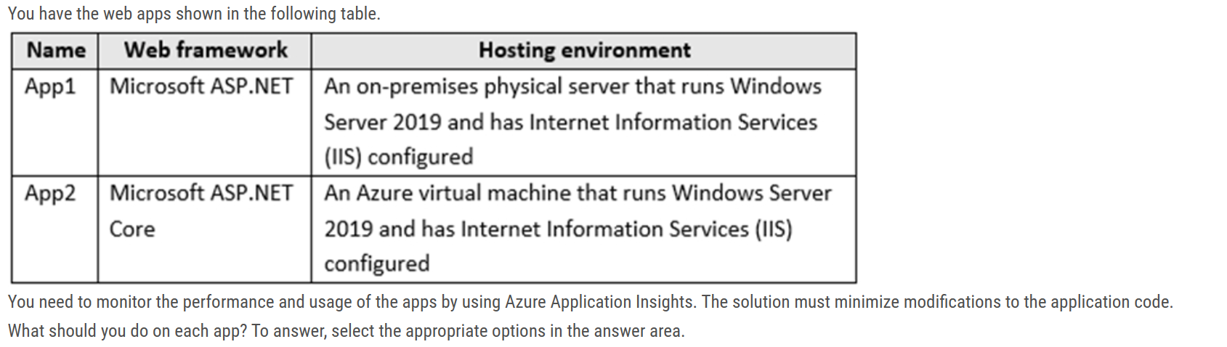

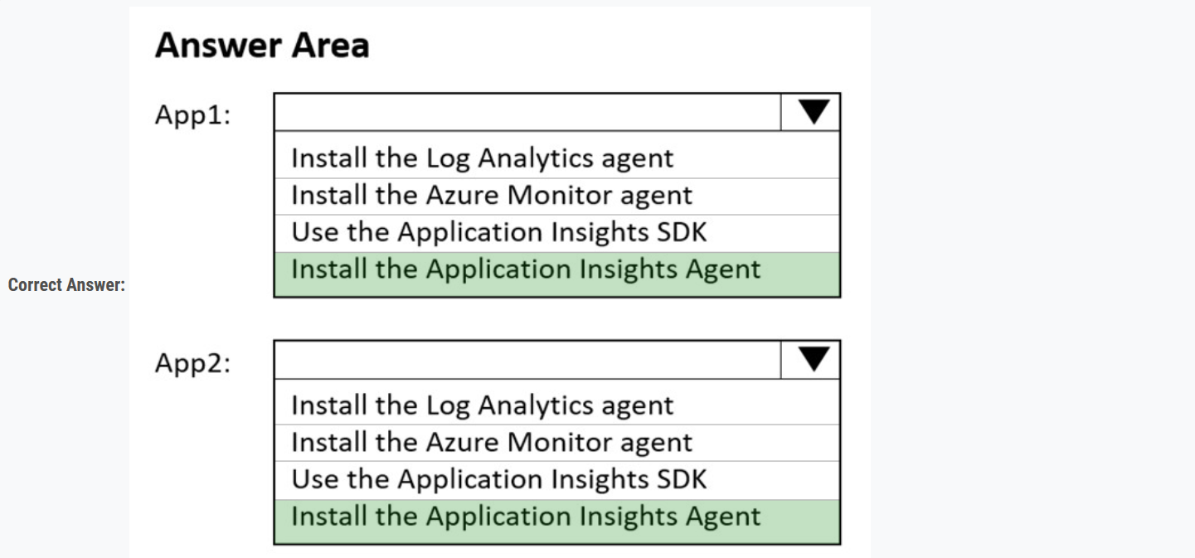

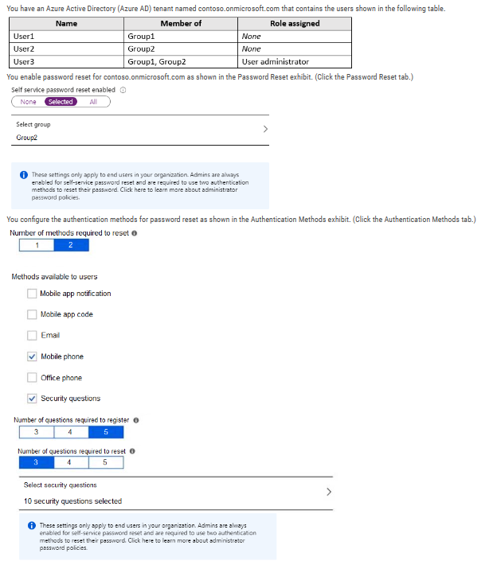

Box 1: No Two methods are required (Mobile phone and Security questions).

Box 2: No Self-service password reset is only enabled for Group2, and User1 is not a member of Group2.

Box 3: No To be able to add Security questions to the process, you need to be a Global Administrator or Authentication Policy Administrator. User3 is User Administrator, so User3 cannot add security questions to the reset process. User Administrator doesn’t have MFA permissions.

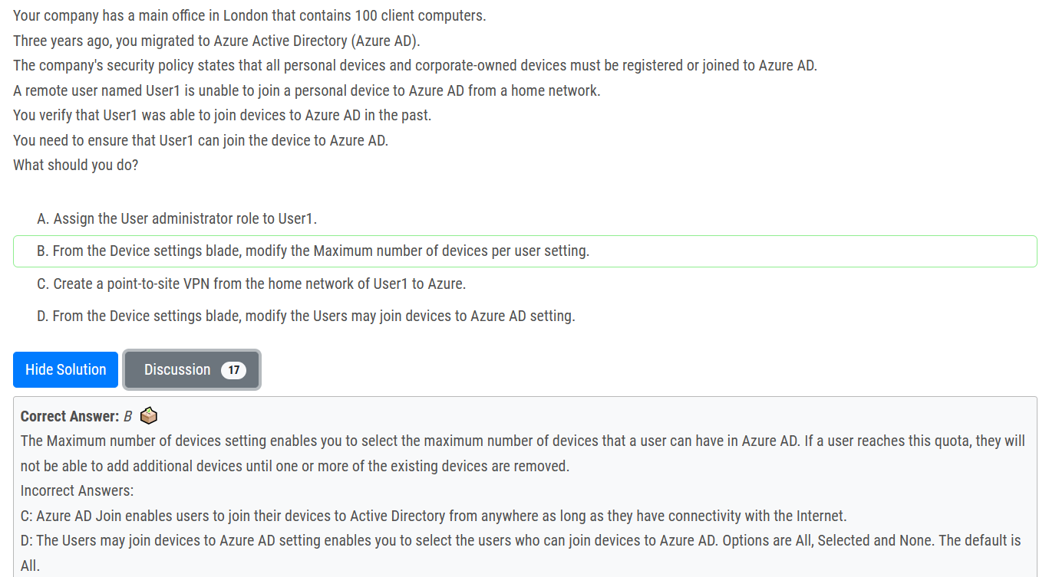

For those who choose D, please read the question carefully, "You verify that User1 was able to join devices to Azure AD in the past." So the join device setting should be ok, but he already reach the maximum number of devices per user. Answer B is correct.

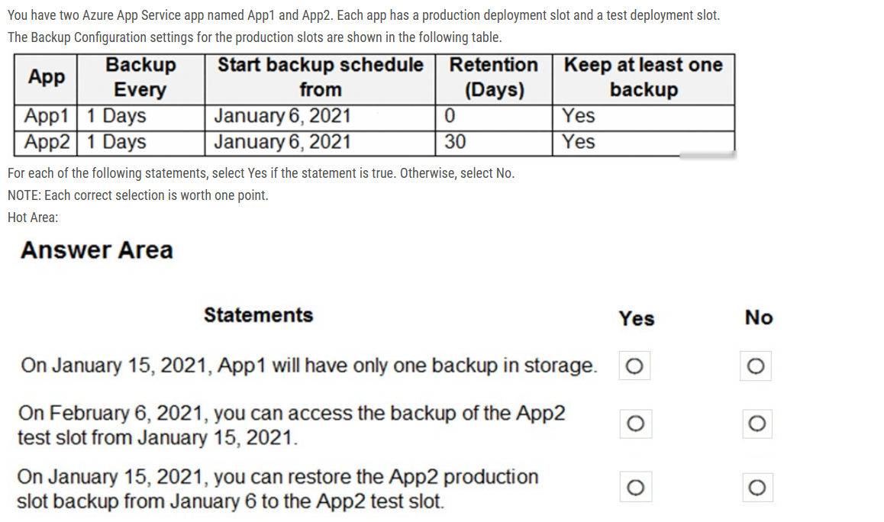

NNY

1. How many days to keep a backup before automatically deleting it. Set to 0 for indefinite retention.

2. didn't mention test slot backup at all

3. we can restore a specific backup to another app (or deployment slot, if specified).

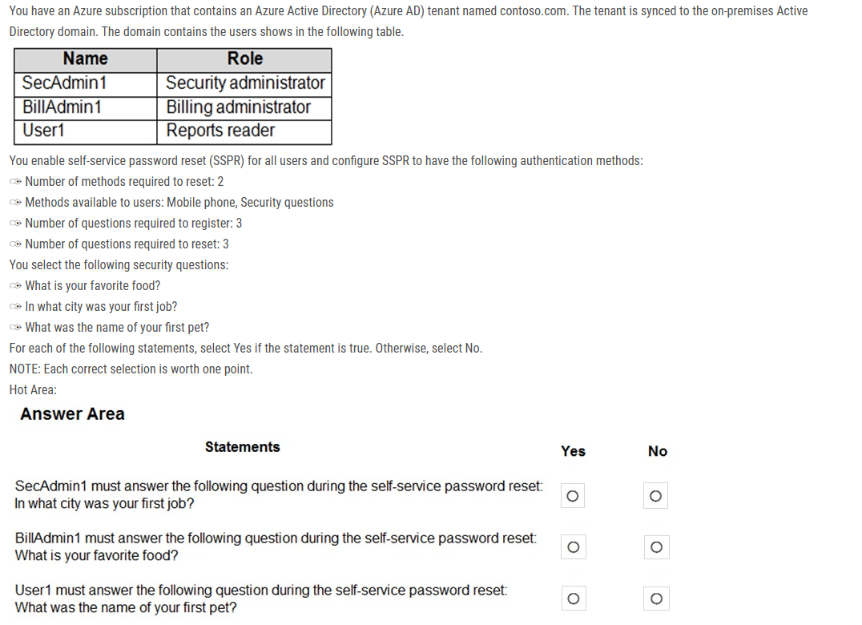

N N Y is the answer.

Security questions aren't used as an authentication method during a sign-in event. Instead, security questions can be used during the self-service password reset (SSPR) process to confirm who you are. Administrator accounts can't use security questions as verification method with SSPR

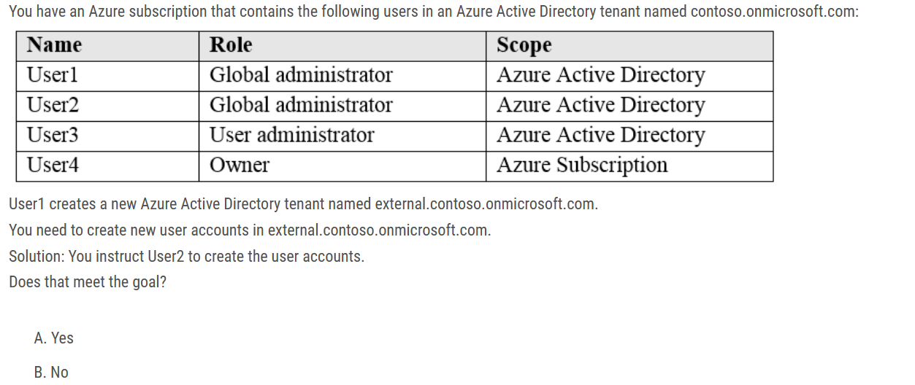

Answer: B

- It is another tenant. User2 is a Global administrator on the original tenant, not on the newly created tenant.

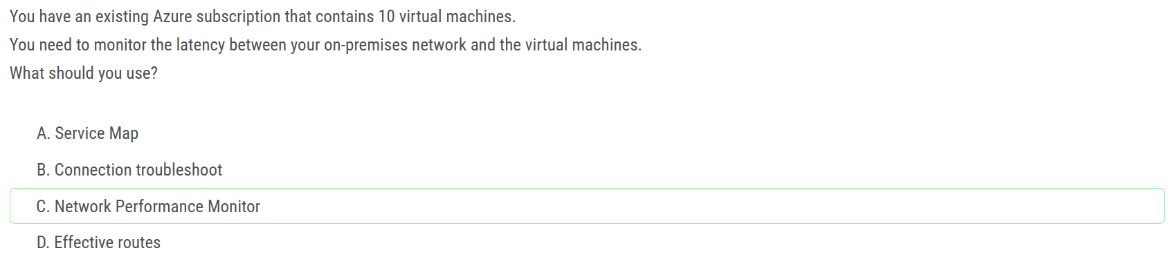

C. Network Performance Monitor is the correct option in this scenario. It provides monitoring and diagnostics tools to help you optimize the performance and availability of your network infrastructure. It can be used to monitor the network connectivity and latency between your on-premises network and Azure resources, including virtual machines. Service Map provides a visual representation of your application and server dependencies, Connection troubleshoot is used for identifying and resolving connection issues, and Effective routes is used to verify the effective routes of a virtual machine's network interface.

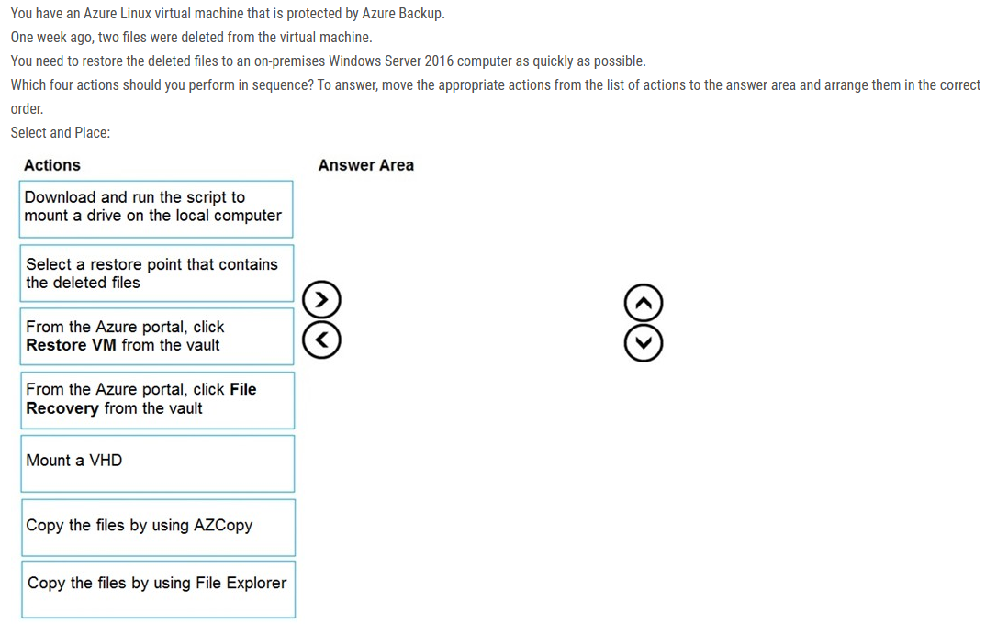

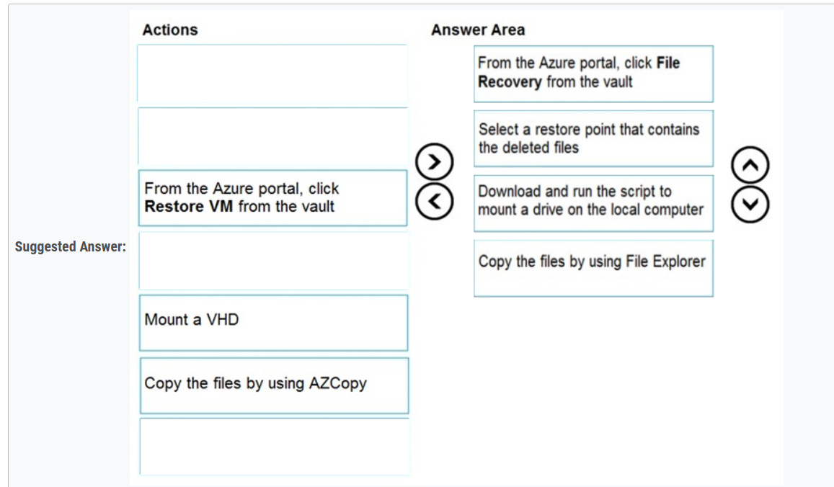

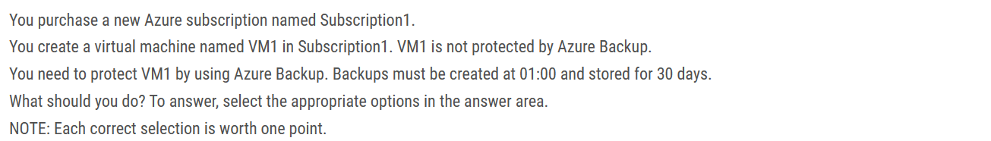

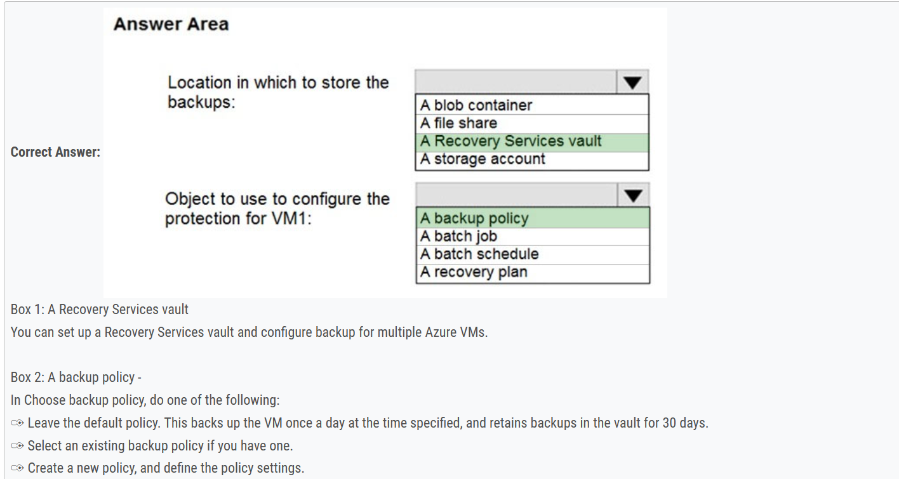

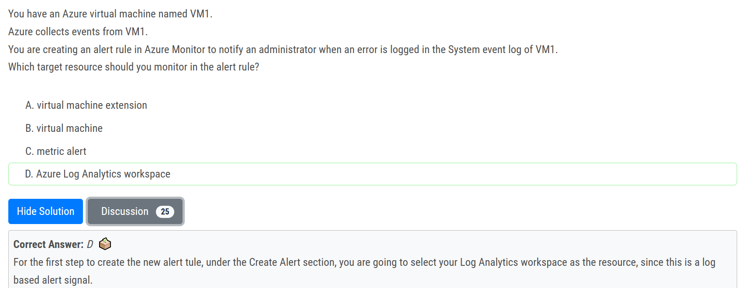

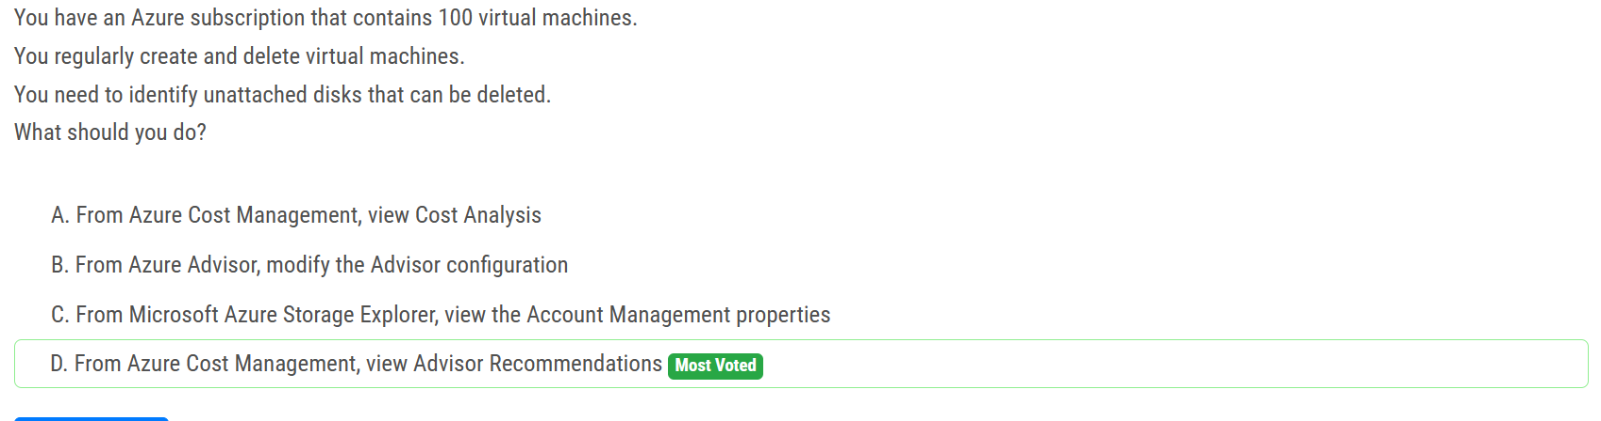

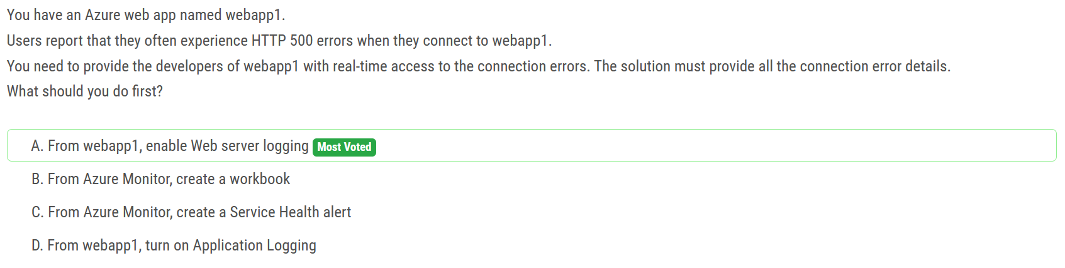

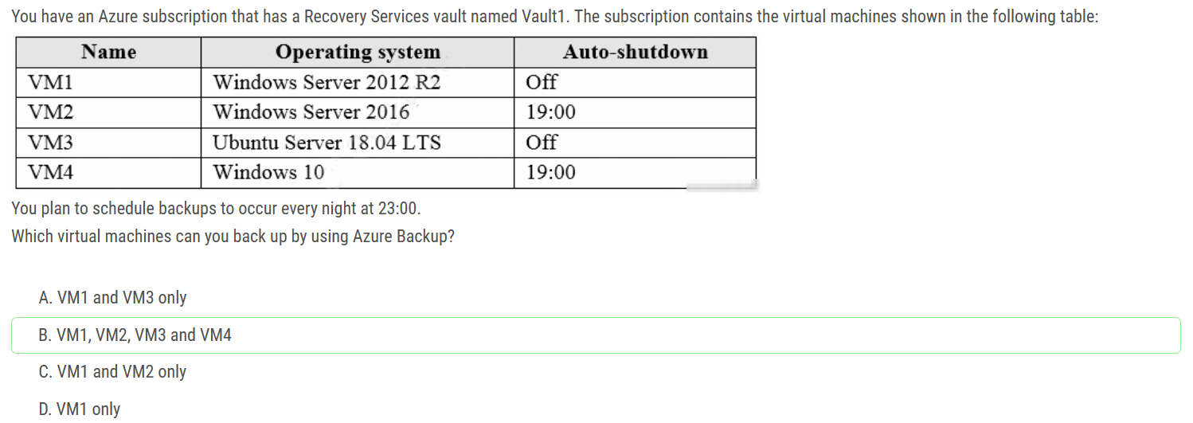

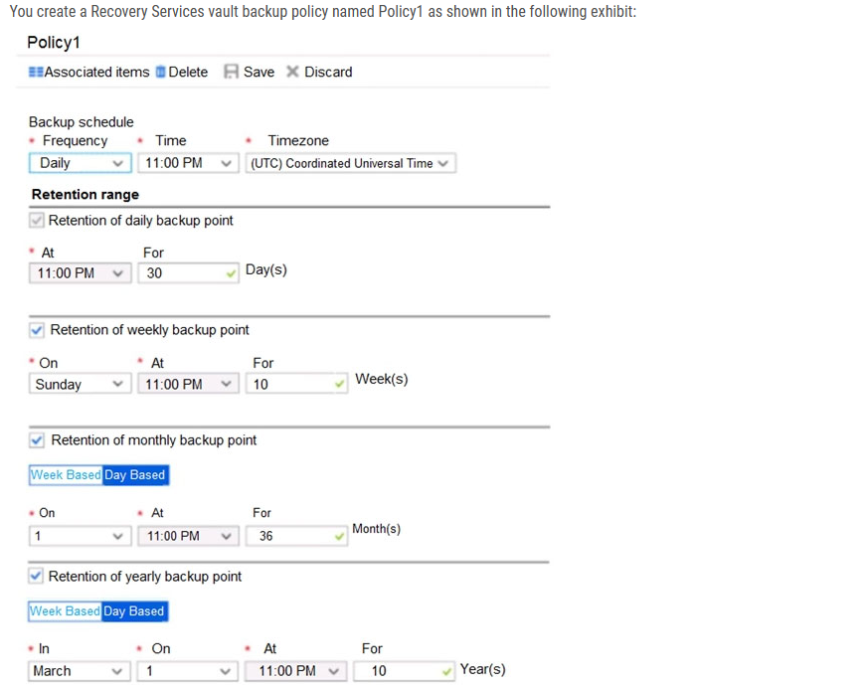

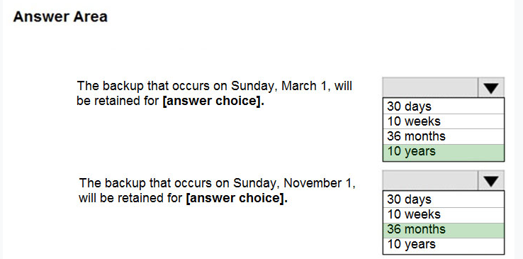

Answer is 10 years and 36 months.

Azure retention policy takes the longest period of retention for each backup. In case of conflict between 2 different policies.

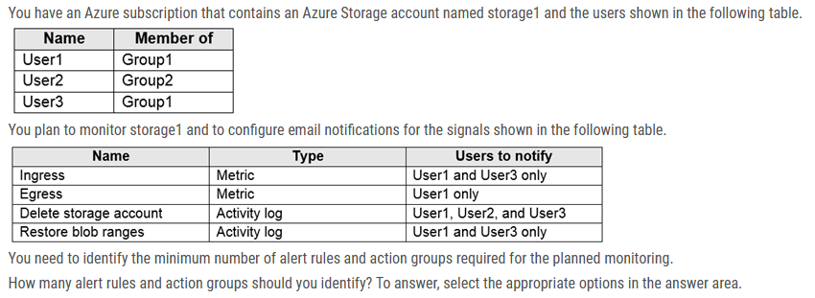

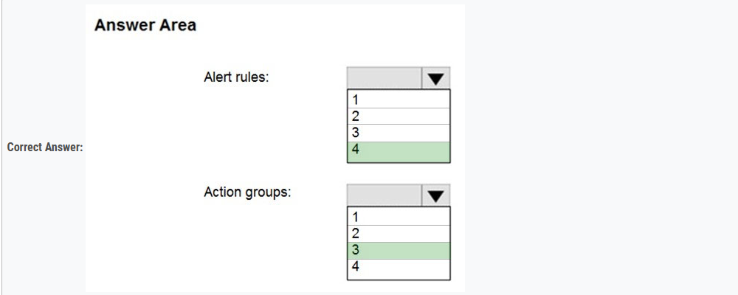

Box 1: 4 You need 1 alert rule per 1 signal (1xIngress, 1xEgress, 1xDelete storage account, 1xRestore blob ranges).

Box 2: 3 You need 3 Action Groups (1xUser1 and User3, 1xUser1 only, 1xUser1 User2 and User3).